Can you help Belle by designing her a new mirror? Use the space provided – be as creative and colourful as you like!

You can also draw a picture of something you have missed during lockdown in the mirror!

Name -

Class -

Design your own mirror!

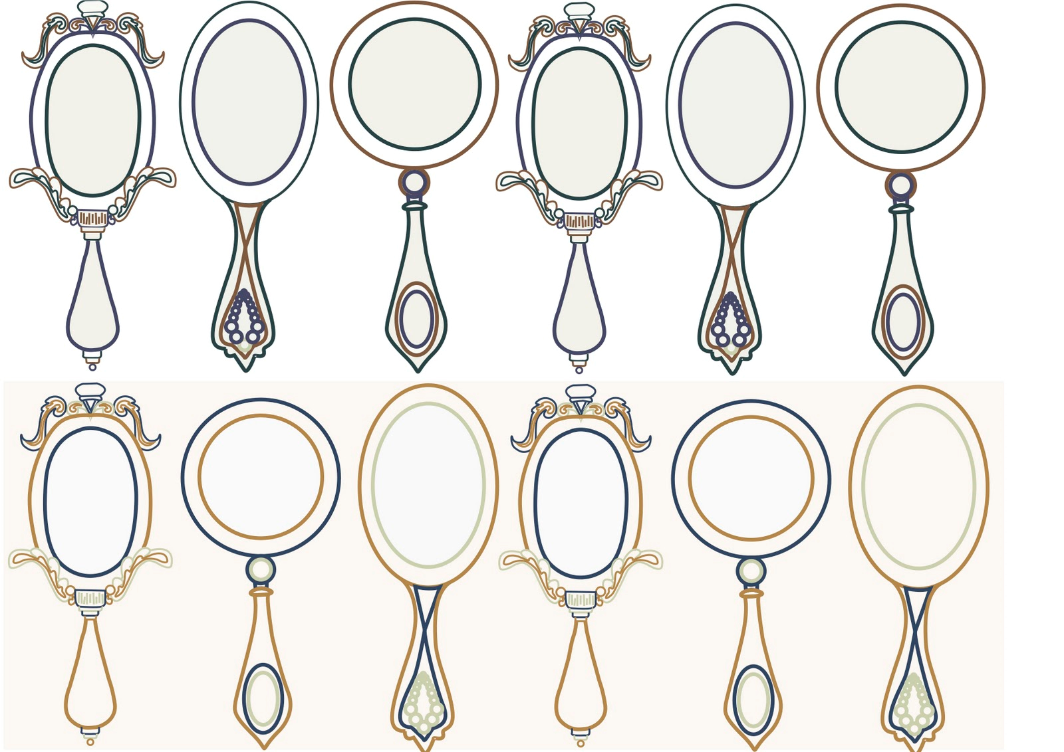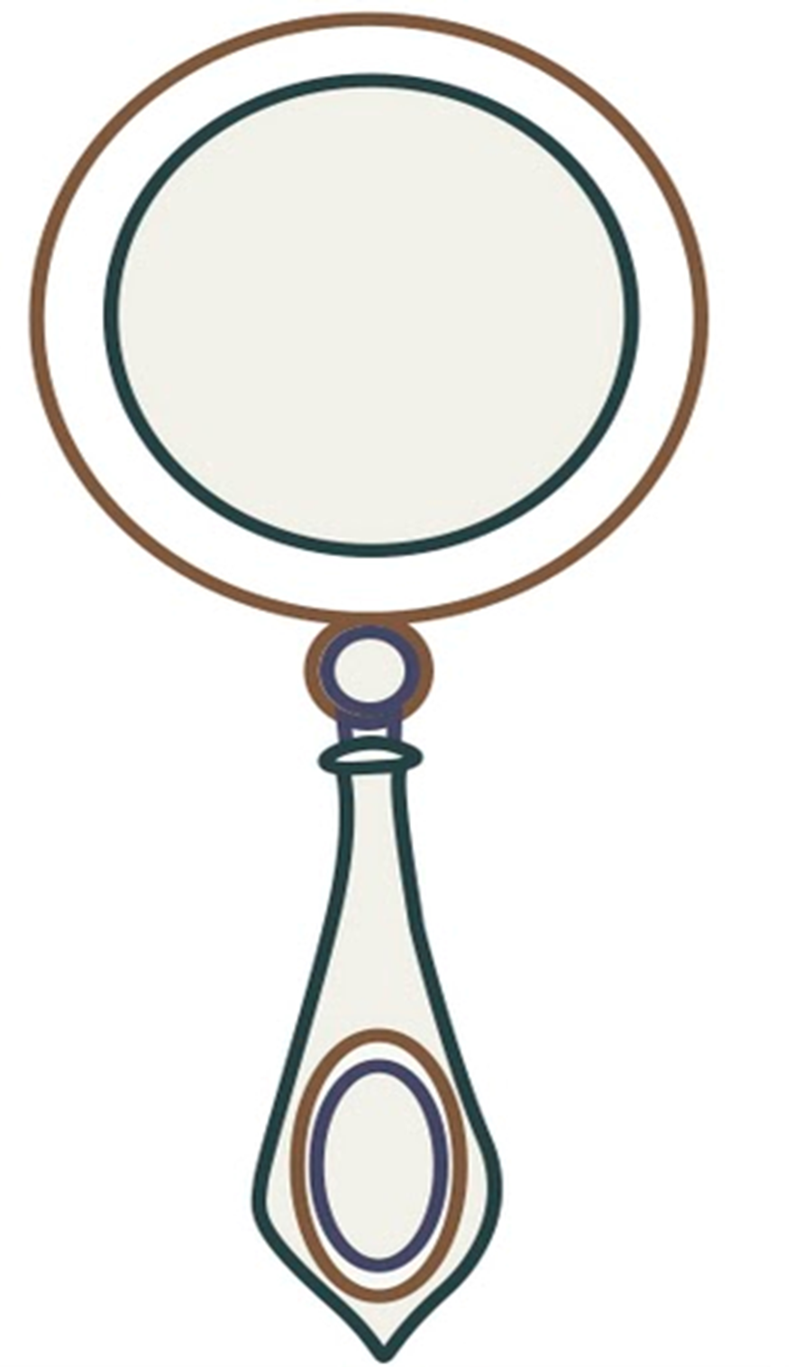

Can you help Belle by colouring in this mirror?

You can also draw a picture of something you have missed during lockdown in the mirror!

Name –

Class –

Design your own mirror!