While watching the video clip outlining Zoe’s daily routine, write and draw the time on the clock provided at which different events occur throughout the day. Please upload your response to the padlet page by using this link: <https://padlet.com/zzw02/ak4181m6xqxoikcy>

**A day in the life of Zoe**

|  |  |  |
| --- | --- | --- |
| **Event** | **Time drawn on 12 hour clock**  (remember the minute and hour hands are different sizes) | **Written time** |
| What time does Zoe  wake up at the morning? |  |  |
| What time does Zoe eat  her breakfast at? |  |  |
| What time does Zoe  start working at? |  |  |
| What time does Zoe  have her lunch at? |  |  |
| What time does Zoe  finish her work at? |  |  |
| What time does Zoe  take her dog for a walk? |  |  |
| What time does Zoe  have her dinner at? |  |  |

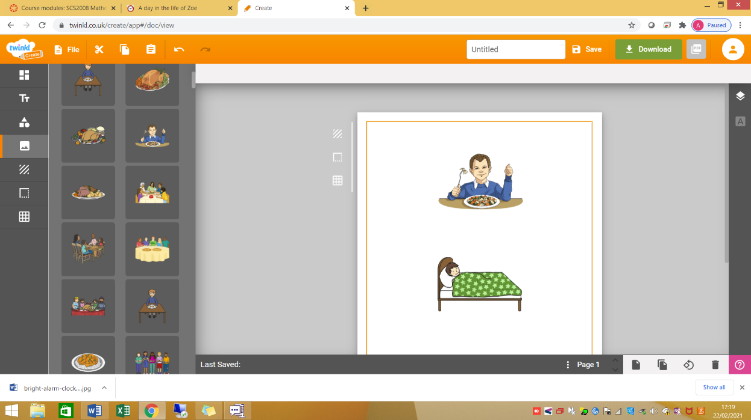

Write down what times does Zoe go to bed at?

Between ____________________________________________________________________ and ________________________________________________________________________