KS2 Money-Ideas for Parents

CCEA (2007):
Pupils should be enabled to:
• use the four operations to solve problems involving money;
- discuss the value of money, how to keep money safe, ways in which goods can be paid for and the need for budgeting;
- be able to plan and think ahead in terms of saving and spending money, prioritise spending with a limited supply of money, understand how to access best buys;




Discussion:

- Why do we need money?
- How would we manage without money?
- Do you spend or save your pocket money?
- What are the pros/cons of pocket money? (this could be asked for children who don’t receive it)

Activities:

- Financial Capability: Ask your child/children to plan a weekly shop in Tesco, with a £100 budget.

CONSIDER…
- Do they choose the cheapest items or the more expensive items?
- How much money has been spent?
- How much money is left over?
- Can they work add up the price as they go a long.

Perhaps you could invite your child to help with a weekly shop, adding up how much it will cost.

- Budgeting lessons can also take the form of a cinema trip, party or redecorating a bedroom.
- Online Games: Super Grocery Shopper (budgeting and money skills)
- Compare two shopping receipts and discuss the savings that could be made.

This will also develop the four operations (addition, subtraction, multiplication and division)

- Foreign Currency:

-Compare the cost of different items in different countries e.g. on holiday
Item | Dollars | Euro | Sterling
A bottle of coke | $1.25 | €2.50 | £1.00
An ice cream | $1.25 | €2.00 | 90p
A cup of coffee | $3.50 | €4.00 | £2.50
A hamburger | $4.50 | €6.00 | £3.50

- The children could estimate the price of an object, using an up to date exchange rate, If the rate is £1 = €1.30, multiply the cost in pounds by 1.30 to get the cost in Euros. For example, 65p: 0.65 x 1.30 = 85 cents.
- These estimates can be checked, using an online converter.
- if possible show the children notes and coins from a number of different currencies. Discuss what characteristics they have in common and what makes them different.
CONSIDER…
- Which currency is the easiest to convert?
- How could you use a calculator to help you?
- Where can you get foreign currency?
- Where could you find information about exchange rates?

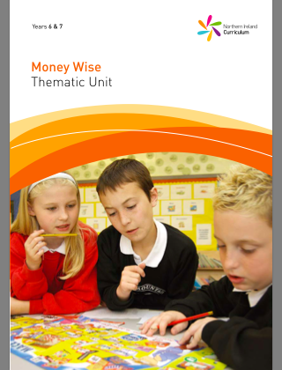
Key Resource: Years 6 & 7 Money Wise Thematic Unit http://www.nicurriculum.org.uk/curriculum_microsite/financial_capability/documents/money_wise.pdf?mc=fin

