
Budgeting

Resource 1

Can you plan a weekly food shop for your family?
Points to remember:
- You only have £100 to spend.
- You need to buy enough food for breakfast, lunch and dinner as well as any other essential items e.g. shampoo, fairy liquid, washing powder.
Item | Price
Total:

How much money is left over?
How much money has been spent?

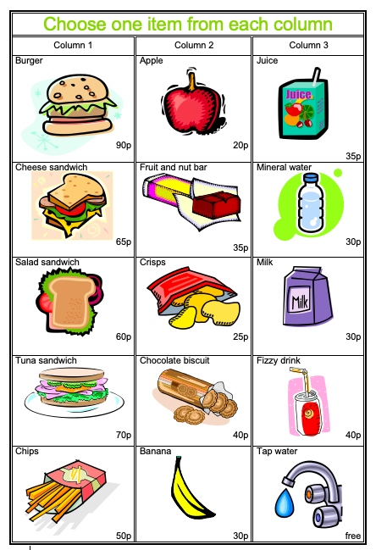
Resource 2
Making a Healthy Lunch

- You are given £2 to spend on lunch each day.
- Record what you are having for lunch each day and calculate the cost.
- Do you have any money left other?-Calculate the change.

 |  | Cost: | Change:
Monday
Tuesday
Wednesday
Thursday
Friday
Currency

- Research the price of the items using the internet. The price will be in pounds.

- Try and convert the currency, using a calculator.
Resource 3

€1=£0.90

$1=£0.74

£1= €1.11

€1=$1.22
$1=€0.82

£1=$1.35

Draw the following below:
Item | Dollars | Euro | Sterling
A bottle of coke
An ice cream
A cup of coffee
A hamburger
Sun Cream
A beach towel
A sandwich
Sunglasses
Sunhat
Goggles

1 Pound

1 Dollar

1 Euro

Savings

Resource 4
Is expensive always better?

Answer the following questions:
Compare the two smart phones:


- Is expensive always better?
- What are you paying the money for?
- Is there always a noticeable difference?

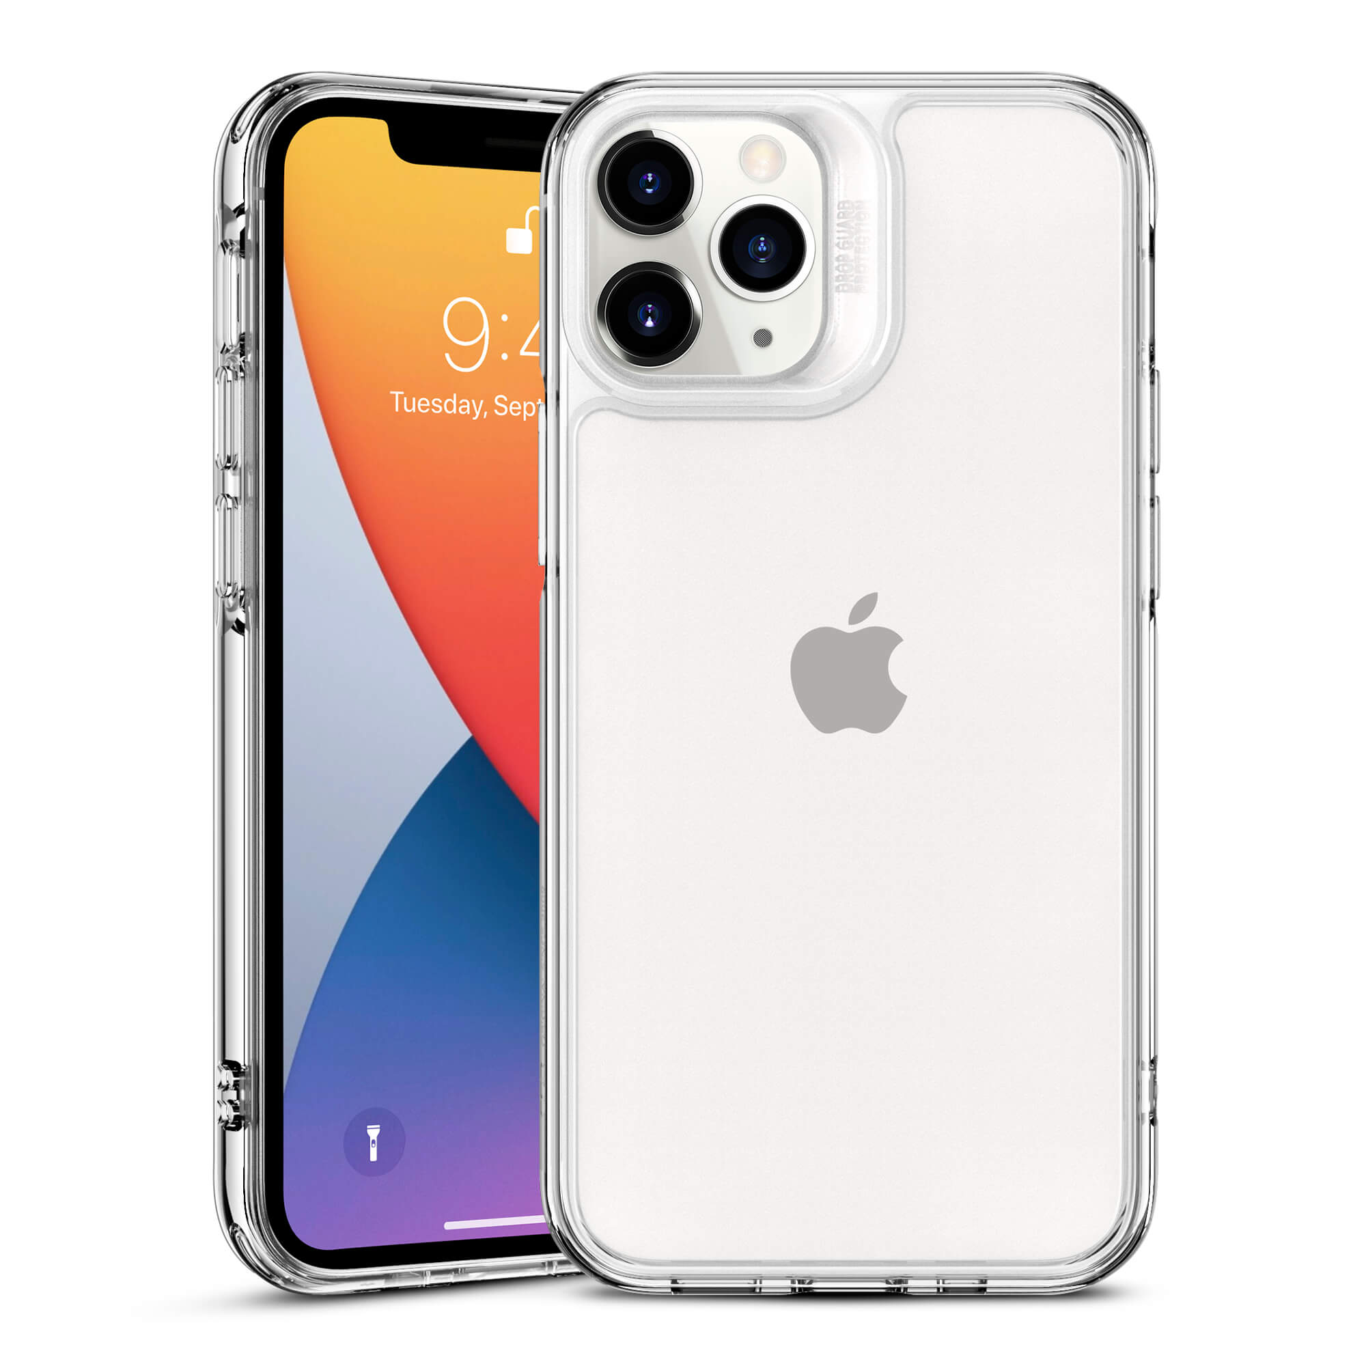

Name: | iPhone 11 | Samsung Galaxy S20 FE
Price: | £699 | £599
Memory: | 64GB | 128GB
Screen Size: | 6.1 inches | 6.4 inches
Battery Life: | 10 hours and 38 minutes | 14 hours and 15 minutes
Colour: | - Green  - Purple  - White  - Yellow  - Red  - Black | - White  - Lavender  - Orange  - Mint  - Red  - Navy

True or False?
- The Samsung is cheaper than the iPhone.
- The iPhone has a better camera than the Samsung.
- The Samsung has more memory than the iPhone.
- The battery of the iPhone is better than the Samsung.

