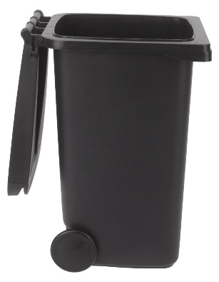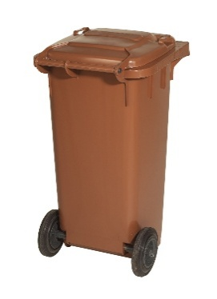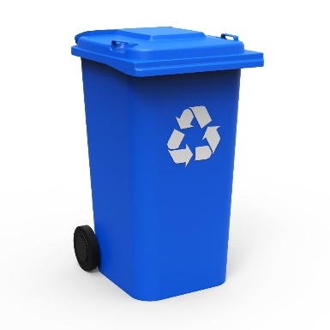**Which bin does the rubbish go in?**

**Black bin- general waste bin**

**Blue bin- recycling bin**

**Brown Bin- compost/food waste bin**

**List of rubbish items for sorting:**

* Crisp bags
* Cardboard
* Food tins/cans
* Food waste
* Bubble wrap
* Hedge trimmings
* Toilet roll tubes
* Broken glass
* Fruit and vegetable peelings
* Empty plastic bottles