

**Bachelor of Education Primary Year 1**

**SPS1005**

**Professional Studies and Placement 1**



**School Based work - Block Placement Spring 2025**

**Information Booklet for students**

**Placement Dates – Spring 2025**

**If possible, unless the school needs to make different arrangements:**

**Block 1 – FS/KS1 - 4 weeks - Monday 17th Feb – Friday 14th March**

**Block 2 – KS2 - 3 weeks - Monday 17th March – Friday 4th April**

**First Block Teaching Pattern**

**FS/KS1 - 4 weeks**

* **Monday 17th Feb observation day**
* **Tuesday 18th Feb: observation day**
* **Wednesday 19th Feb onwards: teach 2 lessons per day**

**Second Block Teaching Pattern**

**KS2 - 3 weeks**

* **Tuesday: 18th Mar observation day**
* **Wednesday: 19th Mar onwards: teach 2 lessons per day**

**If your pattern deviates from this, make sure that you inform your College tutor about what is happening.**

**RE Certificate: Year 1**

* Additional Placement for those undertaking **Certificate in Religious Education** in late May- early June. Students undertaking the Certificate in Religious Education should have the opportunity to teach Religious Education during all their placements.

**SBW Teaching File**

* Create an SBW teaching file on your laptop/ computer (as opposed to printing it all out). This is **not** an ‘**online’** file.
* Your teaching file represents a portfolio of evidence which is reflective of your developing competence in and understanding of the ‘plan-do-review’ cycle, but also is indicative of your professionalism as a teacher. It should be personal to you and to the classes that you are teaching. It should therefore be well organised, carefully laid out and should exhibit high standards of presentation.
* Your College tutor will need to see your file during visits, but you should be sharing and discussing the file with your class teachers (and maybe the school’s principal) on a regular basis.
* It is YOUR responsibility to provide staff with access to your SBW file when they visit. For example you might have everything on your own laptop or have it ready to view on a school computer in the classroom. (Some College laptops are available for loan from IT Services.)
* Your teaching file must be kept up to date on a daily basis during SBW. It is integral to the assessment of your placement. At the bottom of the SBW Report Form which tutors will complete following their visits it states:

*The following areas will be considered before deciding on a grade:*

*1. Review of planning and preparation in the file by the tutor*

*2. Classroom observations by the tutor*

*3. Pre- and post -observation discussions or professional learning conversations between student and tutor*

*4. Feedback from school*

*5. Reflections on teaching, as appropriate for each module*

*6. Demonstration of competences*

*The following areas will ALSO be considered before deciding on a grade:*

*Critical Self-reflection Ability to work independently*

*Flair and originality Demonstration of core values*

*Year-specific issues (see module guide)*

* Print out a copy of the lesson plan for any lessons that will be observed by a College tutor.
* Only write lesson plans for lessons that you will actually teach. You are expected to teach TWO lessons per day. However events such as day trips, visiting drama groups or mornings at the swimming pool will mean that you won’t be able to teach your two lessons - that’s OK. You can still learn by taking part and helping out in these other activities.

**SBW File – folder structure**

Create a folder on your computer called:

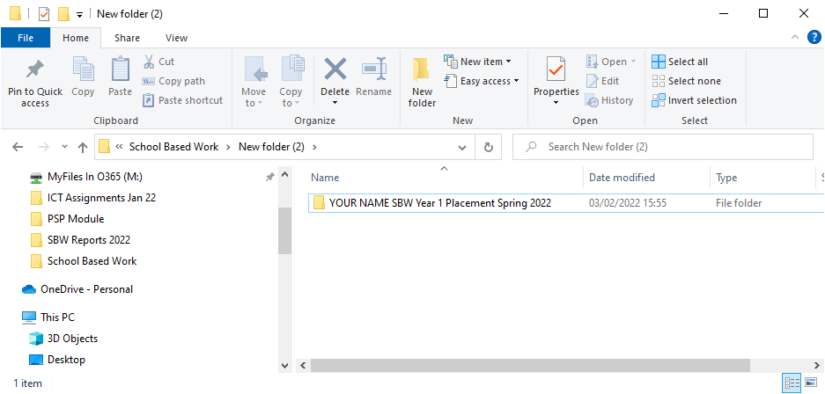**YOUR NAME – SBW Year 1 - Placement Spring 2025**

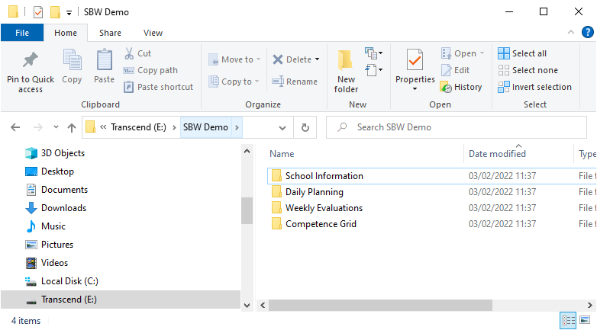

Within this folder create the following sub-folders:

What goes in each of these folders is set out on the following pages.

**School Information folder**

* A Word document with the school name, principal’s name, teachers’ names,  
  class information (first names of children only), any other relevant school information

Ask your teacher about getting electronic copies of the following school policies and   
put them in the School Information folder:

* Safeguarding and Child Protection Policy
* Pastoral Care Policy
* Marking and Feedback policy
* Positive Behaviour Policy
* Health and Safety Policy

We understand that the school may prefer that students simply read these documents rather than have a copy; in that case, add a sentence listing the policy documents that you have read.

For your second class you only need to include class information in this folder relevant to the class to which you have transitioned.

**Please give every document a clear filename.**

**Daily Planning folder - create a folder for each week:**

**In each week’s folder include**

* The 2 lesson planners for each day (see template on Canvas)
* Any lesson resources – e.g. worksheets, PowerPoints etc.
* Samples of children’s work if possible/applicable (these can be photos)
* Any other materials or information relevant to the lesson **Please give every document a clear filename, e.g. Fri 25 Feb Literacy Lesson Plan**

**Fri 25 Feb Literacy PowerPoint**

**Fri 25 Feb Literacy worksheet**

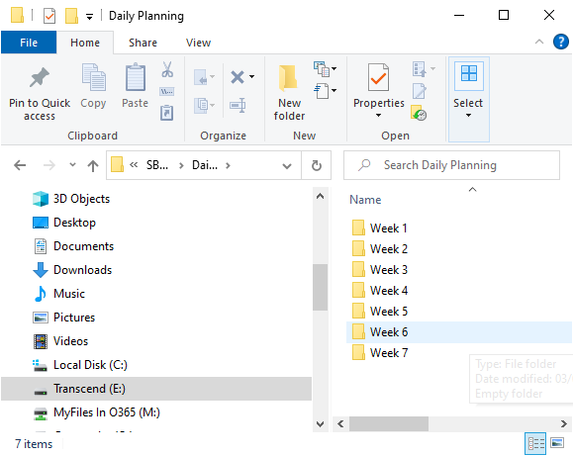

**Weekly Evaluations Folder - place a completed weekly evaluation grid document into this folder at the end of each week.**

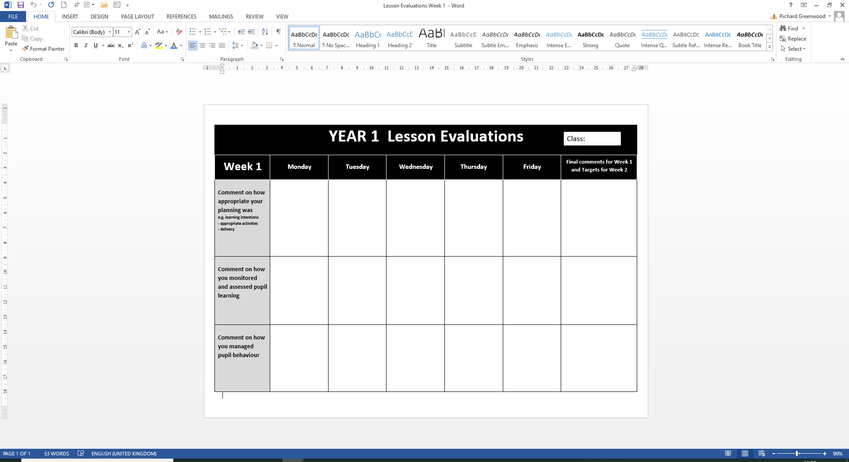

**Please give every document a clear filename, e.g.**

**Week 1 Weekly Evaluation**

**Competence Grid folder**

GTCNI Competences

The GTCNI booklet *‘Teaching: the Reflective Profession’* was referred to in a PSP intro ‘lecture’ in October. It’s in the PSP course in Canvas and also can be found at this link:

<https://gtcni.org.uk/cmsfiles/Resource365/Resources/Publications/The_Reflective_Profession.pdf>

Every year we ask students to reflect on what competences they have achieved using a Formative Profile Report at the end of Placement. In order to help streamline processes for this academic year we are asking students to keep a working document during placement, noting whenever they are generating evidence for each GTCNI competence.

For example, Competence 20 states:

***Use a range of teaching strategies and resources, including eLearning where appropriate, that enable learning to take place and which maintain pace within lessons and over time.***

If you then produce a really good lesson plan that demonstrates effective e-learning, you may wish to note this as evidence of Competence 20 in the Competence grid.

See the next page for the Competences to be focussed on in Year 1.

**The following competences are the ones to be concentrated on by Year 1 Primary students:**

**Professional Competence 3:**

Teachers will have developed a knowledge and understanding of the learning area/subjects(s) they teach, including the centrality of strategies and initiatives to improve literacy, numeracy and thinking skills, keeping curricular, subject and pedagogical knowledge up-to-date through reflection, self study and collaboration with colleagues

**Professional Competence 4:**

Teachers will have developed a knowledge and understanding of how the learning area/subject(s) they teach contribute to the Northern Ireland Curriculum and be aware of curriculum requirements in preceding and subsequent key stages

**Professional Competence 6:**

Teachers will have developed a knowledge and understanding of the factors that promote and hinder effective learning, and be aware of the need to provide for the holistic development of the child.

Consider the key aspects of emotional and behavioural difficulties; trauma, child abuse, bullying, discrimination, stereotyping, and pupil mobility or absence from school.

**Professional Competence 7:**

Teachers will have developed a knowledge and understanding of a range of strategies to promote and maintain positive behaviour, including an acknowledgement of pupil voice, to establish an effective learning environment.

**Professional Competence 10a:**

Teachers will have developed a knowledge and understanding of strategies for communicating effectively with pupils

**Professional Competence 11b:**

Teachers will have developed a knowledge and understanding of how to use technology effectively to aid pupil learning

**Professional Competence 14:**

Teachers will set appropriate learning objectives/outcomes/intentions, taking account of what pupils know, understand and can do, and the demands of the Northern Ireland Curriculum in terms of knowledge, skills acquisition and progression

**Professional Competence 15:**

Teachers will plan and evaluate lessons that enable all pupils, including those with special educational needs, to meet learning objectives/outcomes/intentions, showing high expectations and an awareness of potential areas of difficulty

**Professional Competence 19:**

Teachers will create and maintain a safe, interactive and challenging learning environment, with appropriate clarity of purpose for activities

**Professional Competence 20:**

Teachers will use a range of teaching strategies and resources, including e-learning where appropriate, that enable learning to take place and which maintain pace within lessons and over time

**Online File**

**Before Placement Starts**: create exactly the same folder structure on OneDrive before the start of SBW – by 5:00pm on 14th February – and share with your College tutor. Upload planners, materials, weekly evaluations etc. to this every few days so that tutors can monitor student progress as required.

**At the end of SBW:** make sure that all of the contents of your SBW file are on OneDrive so that your tutor can have a final look through it. The deadline for doing this is **Monday 7th April**. If you have been keeping it all up to date as you should have been, there will be nothing much to do to your file after the end of SBW except for the final week’s evaluation and completion of the Competences Grid.

**Student Support**

You will have a weekly group meeting on Teams with your tutor and other students as placement progresses. These may be on Friday afternoons, and they can be a time to address common issues and seek support from other students as well as your tutor and will give students the opportunity to connect weekly. As the practice goes on, you may feel that these meetings are not necessary, so they may become less frequent, but you can always email your tutor with your queries.