SPS1003
Personal and Professional Learning 1

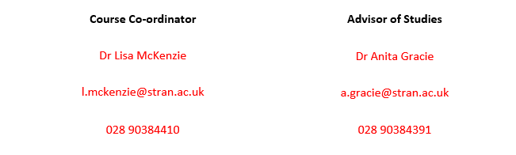





P4: Professional Behaviour
P3: Professional Partnership
P1: Professional Knowledge

Professional standards Sustainability goals



Bachelor of Education (Post-Primary) Course Guide
Module number: SPS1003
2025-2026

Section A: Course Information

Course Content
Welcome to the Personal and Professional Learning 1 (PPL1) module. Personal and professional learning lies at the heart of the journey to becoming a successful teacher and, within this course, you will have the opportunity to draw the personal and professional aspects of your learning together. You will develop your personal abilities in a range of areas including literacy, numeracy and UICT and, through your school based work (SBW), you will start to build professional competence in the classroom. The specific content is as follows:
- Practical teaching based on GTC Competences;
- Lesson planning and reflection;
- Effective lesson delivery;
- Subject specific pedagogical skills (as appropriate);
- Personal and professional ICT, literacy, numeracy, Learning for Life and Work, personal study skills, child protection and safeguarding.
Learning Outcomes
By the end of the course students should be able to:
- Plan lessons in their applicable subjects and other areas such as LLW;
- Deliver lessons competently in their applicable subjects and other areas such as LLW;
- Reflect on their teaching using the GTCNI competences;
- Develop personal skills in UICT, literacy, numeracy and study skills;
- Develop awareness of child protection and safeguarding procedures for school-based work (SBW).
Skills
Students should be able to:
- Use ICT in their study and in their placement setting as appropriate;
- Communicate effectively with peers, pupils and other professionals orally and in writing;
- Collaborate and plan as part of a team.

Content and delivery is structured around the following two themes:
- School Based Work (SBW) preparation - SBW experience (graded); First Subject Application; Second Subject Application
- Professional Studies: Literacy, Numeracy, Using ICT, LLW, child protection and safeguarding.

A separate outline of subject application, literacy, numeracy and UICT classes will be provided by your specialist class tutor.

School placement is central to your professional learning
- Planning for teaching will take place in Subject application classes before Christmas.
- You will be informed by placements team about accessing details of your allocated school in the online placement software (via email)

- Dates of school placement in a primary school are provided below:

Day visits |  | - 1 diversity day visit before reading week, Monday 13th October 2025 (TBC): further details to follow from Roberta Crawford)
  Mon 3 Nov 2025
  Mon 10 Nov 2025
  Mon 17 Nov 2025
  Mon 24 Nov 2025
  Mon 1 Dec 2025
  Mon 8 Dec 2025
  6 day visits prior to Christmas
Observation Week | Monday 12 January - Friday 16 January 2026
Block Practice |  | - This will involve planning, teaching and evaluation of lessons;  - Students are required to teach 7-9 hours per week;  - For those undertaking the Certificate in Religious Education the final three weeks (dates to be confirmed) will be in a maintained school. Students should have the opportunity to teach Religious Education.
  Monday 9 February 2026 –
  Friday 27 March 2026
  7 week block placement
Additional Placement for those undertaking the Certificate in Religious Education | Monday 1st June 2026 - Friday 19th June 2026 | - This will involve planning, teaching and evaluation of lessons;  - Students are required to teach 7-9 hours per week;  - Students should have the opportunity to teach Religious Education;  - Further details to follow from Dr Anita Gracie.

Additional assessment for those undertaking the Certificate in Religious Education will be undertaken outside this module Monday 1st June 2026 - Friday 19th June 2026. Details will be provided by your tutor, Dr Anita Gracie.

Professional Learning in a Changing Society (PLiCS) Year 1:
Professional Learning in a Changing Society (PLiCS) is a central element of the BEd programme, running throughout all four years of undergraduate study. Jointly developed by Stranmillis University College and St Mary’s University College, PLiCS is designed to equip student teachers with the knowledge, skills, and mindset needed to thrive in today’s increasingly diverse classrooms and rapidly evolving educational landscape.
On your timetable, you will notice a number of compulsory events planned for Semester 1, these arrangements will replace your normal timetable below and you are expected to attend both events. This will be an intra-college event only this year.
Monday 6 October 2025 | BEd 1 Primary and Post-primary students | 0930-1330 | Location: Stranmillis University College
Monday 13 October 2025 | BEd 1 Primary and Post-primary students | 0930-1330 (approx.) | Location: Individual schools as allocated by tutor
Monday 20 October 2025 | BEd 1 Primary and Post-primary students | 0930-1330 | Location: Stranmillis University College
Further details will be forwarded via email in advance of the events.

Course Requirements

Pre-requisite: None
Compulsory: Students must pass the school-based placement element.

All assignment details will be uploaded separately online via Canvas and further details on how to submit in this way will be provided during the course. An overview of assessment for the module is provided on pages 6 and 7.
  - Further assignment details and submission dates will be provided in the first few weeks of term. These will also be available on Canvas.
  - The micro-teach elements will be discussed in your Subject Application classes with your course tutor.
  - The SBW and assessment elements will be discussed in Professional Studies (class on Wednesday).

Student Feedback
Based on feedback received from students last year (n=11), the following features have been retained:
- Students commented positively on being able to talk to students from other subjects;
- Use of guest speakers;
- Learning how to become a good teacher;
- Placement.
The following changes have been made:
- The aspects/elements identified above will continue to be incorporated and adapted as deemed appropriate to prepare students for their placement in the primary school.
- Further preparation for the primary school placement to take place prior to SBW.
- Additional sessions have been organised to help prepare students for life in a primary school and assist in preparation of a lesson for the primary school classroom.
Some students commented on the class size and room facilities; these have been considered as much as possible in the schedule for 2025-2026.

Useful Information
Please refer to the BEd Programme Handbook (available on the intranet) for further information, including:
- General Regulations for all University courses
- The examination process
- Assessment mark schemes, i.e., QUB conceptual equivalents
- Plagiarism regulations
- Guide to using the Harvard Reference System

Please check the information available on Canvas in relation to ‘Referencing and academic writing support’. This is a very important academic skill throughout your B.Ed. course.

A number of relevant documents needed for your practical teaching are included in the appendices. These will all be referred to throughout the module and will be available on Canvas.

TEACHING AND LEARNING

Teaching methods include lectures, seminars and workshops. Please ensure you check your individual electronic timetable and email regularly for class details.

Topics for reading and research will be suggested in your classes to help you develop your professional practice. Throughout this course students are encouraged to consider the applications and implications of the various taught elements on their school-based work and wider professional practice.

GTC(NI) Competences

GTCNI Competences
Central to students’ professional preparation is the great emphasis placed on the acquisition of professional competences. The competences are set out in full in the document: ‘Teaching: The Reflective Profession’ produced by the General Teaching Council of Northern Ireland (GTCNI). The booklet can be found on the Web at the URL below:
http://www.gtcni.org.uk/uploads/docs/GTCNI_Bookmarked%20Final%2013th%20June%2007.pdf



Students will explore and develop competence in relation to the following key areas during this module:

Professional Competence 1: Uphold and understand the core values of the profession

Professional Competence 3: A detailed knowledge and understanding of the learning area/subject(s) taught, including the centrality of strategies and initiatives to improve literacy, numeracy and thinking skills to all areas of learning. Have relevant curricular, subject and pedagogical knowledge.

Professional Competence 4: A knowledge and understanding of how the learning area/subject(s) they teach contributes to the Northern Ireland curriculum.

Professional Competence 6: Teachers will have developed a knowledge and understanding of the factors that promote and hinder effective learning, and be aware of the need to provide for the holistic development of the child.

Professional Competence 7: knowledge and understanding of a range of strategies to promote and maintain positive behaviour, including an acknowledgement of pupil voice, to establish
an effective learning environment.

Professional Competence 10: Teachers will have developed a knowledge and understanding of strategies for communicating effectively with pupils.

Professional Competence 11: a knowledge and understanding of how to use technology effectively, both to aid pupil learning and to support their professional role, and how this competence
embeds across all of the competences.

Professional Competence 14: Learning objectives are set that take account of what pupils know, understand and can do. Learning objectives are set to take account of what pupils need to know in relation to the requirements of the Northern Ireland Curriculum.

Professional Competence 15: Lesson plans show clear objectives, relevant content, resources and well-sequenced activities. Plans show high, but realistic, expectations bearing in mind the age and attainment range of the class. Plans show an awareness of areas of potential difficulty and confusion for pupils.

Professional Competence 19: Appreciate the importance of creating a safe, interactive and challenging learning environment and how others seek to create such an environment. Learn from others how to set up purposeful activities.

Professional Competence 20: Use a range of teaching strategies appropriate to the age, ability, interests and experiences of pupils. Use resources that motivate and support all pupils’ learning. Capture and maintain pupils’ attention, interest and involvement through the choice of teaching strategy and resources.

Professional Competence 24: Monitor pupils’ progress through observation, marking, targeted questioning, and discussion. Offer immediate feedback to reinforce learning, challenge pupils’ understanding and promote progression. Mark against the planned learning objectives and note strengths as well as areas for improvement. Use effective questioning and self-assessment tasks for pupils to reflect on and improve their learning.

Professional Competence 25: Select from a range of assessment strategies to evaluate pupils’ learning, and use this information in their planning to help make their teaching more effective.

Section B: Course Outline

A number of staff are involved in the delivery of this module:

CH = Claire Heaney  LMcK = Dr Lisa McKenzie  AG = Dr Anita Gracie | MI = Dr Michael Ievers  IB = Dr Irene Bell  JMc = Dr John McCullagh  RC = Mrs Roberta Crawford |  | IS = Mr Ian Simons  RC = Dr Rachel Campbell  WK = Dr William Kitchen

Assessment
This course will be assessed at Level 1 of the QUB Conceptual Equivalents Scale as outlined in the Assessment Mark Scheme in the BEd Programme Handbook. These are also available at
https://www.qub.ac.uk/directorates/media/Media,837251,smxx.pdf and a copy has been uploaded to your assessment folder on Canvas.

Assessment: 30% practical (SBW) and 70% coursework. The following diagram shows the module assessment details.

Assessment

Practical (SBW)
30%
Coursework
70%

Micro-teach (subsidiary subject)
15%
70%
Micro-teach (main subject)
15%

Professional in the school
(Reflection on diversity and inclusion, CP&SG)
10%
Professional in the classroom
(Reflection, google classroom)
30%

Learning outcomes
1, 2, 3, 4, 5
Learning outcomes
1, 2, 3, 4
Learning outcomes
1, 2, 3, 4
Learning outcomes
3, 5
Learning outcome
1, 4

Compulsory: Students must pass the school-based placement element

Course Assessment – Submission and Deadlines

- Practical SBW (graded placement) (30%)
  - Individual placement primary school; dates as per page 2

Monday 17 February 2025 – Friday 4 April 2025
7 week block placement
Verbal feedback will be given post-lesson delivery and the formal written report will follow within 4 working weeks. This will vary depending on when the micro-teach delivery takes place.

- Coursework (70%) 4 elements
1) Main Subject Micro-teach (15%)
2) Subsidiary Subject Micro-teach (15%)
  - Preparation for classroom practice
For each of your subject areas (e.g. T&D AND PE) the tutor will assess your micro-teach session (10 minutes), using the SBW template and teaching competences. In some cases, such as PE, separate details of the tasks required will be provided by subject tutors

All lesson plans and resources to be used in micro-teach, irrespective of when you are delivering in class, should be uploaded by Friday 31 October 2025 (with the exception of PE which is timetabled Semester 2)

Verbal feedback will be given post-lesson delivery and the formal written report will follow within 4 working weeks of the microteach taking place. Dates will be provided by your subject tutor.

3) Focus: Professional in the classroom (worth 30% of module total)
- Reflection (worth 15% of module total):
- Building a digital teaching space: using Google Classroom to Support Teaching and Learning (worth 15% of module total)
To be completed by Friday 8th May 2026 by 5pm.

Feedback on this element of assessment will take place by 5th June 2026.

4) Focus: Professional in the school (worth 10% of module total – equal marks for both elements)
- Diversity and inclusion
- Child protection and safeguarding
To be completed by Wednesday 1st April 2026 by 5pm.

Feedback on this element of assessment will take place by Wednesday 29 April 2026.

The time taken to return assessed work to students may vary according to the nature of the work and the size of the class, etc. However, lecturers will agree dates for the return of assessed work with relevant grades and written feedback. This will not normally exceed four weeks from the date of submission, dates are available above. Grades provided at this stage will be provisional, subject to the agreement of the Programme External Examiner and confirmation by the Board of Examiners.

Assessment of Subject Application (Main and Second subject micro-teach)

Both elements of Subject Application focus upon microteaching: i.e. students will prepare and present part of a lesson of 10 minutes duration to their peers during their Stranmillis classes, elements of which will be videoed. This will take place face to face on campus and will be agreed in advance with your Subject Application tutor. During the micro-teach, the students will be assessed by their tutor against the standard SBW reporting template and competences as appropriate. Your peers will also provide feedback informally.

By Friday 31 October 2025 (with the exception of PE which is timetabled Semester 2), all students are required to produce and upload the following to Canvas:
- A detailed lesson plan for the whole lesson should be completed (level/topic to be agreed with tutor in advance);
- The micro-teach should be the first 10 minutes of the whole lesson planned;
- A variety of engaging activities and resources should be created to aid delivery.
- As you plan, you should consider the resources, the strategies, timings, key questions, learning intentions, success criteria (if appropriate), assessment;
- During delivery you should consider your posture, use of voice, questioning technique adopted, rapport and engagement with students;
- Please ensure you make arrangements with a peer to have your microteach recorded to aid your post-lesson reflection.

Following the microteach you should complete a written evaluation of the lesson (no more than 500 words): this aspect could be in video or written format. Focus on two strengths of your lesson and one aspect for development. You should draw upon feedback from your peers and your tutor following the micro-teach. No academic references are needed.

You should submit the evaluation, video and appropriate assignment cover sheet online to the relevant folder on Canvas. Try to upload as few files as possible eg one video file and one word file containing the lesson plan, resources and evaluation. The advanced planning, the micro-teach and the subsequent evaluation will all form part of the final grade awarded.

Final date for submission by Friday 13th February 2026 …. before SBW begins (with the exception of PE which is timetabled Semester 2). Recommended individuals submit within one week of micro-teach taking place.
The final mark for the module will be available at the end of the academic year following the formal Examination Board by Friday 5th June 2026.

Content of Professional Studies:
This includes aspects of SBW preparation (LMcK), Numeracy (tbc), Literacy (SD), UICT (RC) and LLW (LMcK).

Additional details on the course and assessment will be provided by the individual lecturer responsible for the cross-curricular skill element. Teaching of literacy and UICT will take place in semester 1 and teaching of numeracy will take place in semester 2.
- Literacy will focus on personal literacy, Using Communication from KS2 onwards, literacy across the curriculum in all subject areas, the role of the literacy coordinator, literacy difficulties and providing a literacy rich environment;
  - The following is a useful website to help with literacy: Free Online English | PGCE | Functional Skills | GCSE Equivalency (literacyskillstest.co.uk).

- Numeracy will focus on Using Maths at key stage 3, Mathematics in specific subject areas, numeracy interventions and the role of the numeracy co-ordinator.
  - An additional session on ‘Numeracy in the primary school’ will also be delivered by Dr Bell

- UICT will focus on the use of ICT as a cross-curricular skill and as a tool to aid classroom delivery.

Content of Subject Application
Within your subject application classes, you will cover aspects of lesson planning with specific reference to your subject area. This will include the following:
- Access relevant statements of minimum entitlement and specifications for subject areas;
- Effective teaching and learning in your subject area;
- Identification of and use of subject-based resources;
- Devising age-appropriate classroom resources (eg worksheets, powerpoint);
- Lesson structure (introduction, development, plenary) and timings;
  - (session provided in Professional Studies);
- Devising appropriate learning intentions and success criteria;
- Use of questioning;
- Lesson reflections and evaluation (to prepare for microteach and placement);
  - (session provided in Professional Studies);
- Use of subject specific resources/materials.

Schedule (the content is as below, however the schedule may be subject to change)
Sessions are planned for face-to-face delivery. If any changes need to be made, you will be informed of any changes via email and/or announcements on Canvas. It is your responsibility to check this regularly.

Week No. |  | Week Commencing |  | Professional Studies  (Wednesday 11am -12 noon)
1 |  | 22nd Sept 2025 |  | - Introduction to module and assessment  - Planning for university; study skills, academic writing  - Planning for teaching
2 |  | 29th Sept 2025 |  | - Introduction to lesson planning 1 (lesson structure, learning intentions and success criteria)  - Teaching strategies and activities: engaging the pupils
3 |  | 6th Oct 2025 |  | - Introduction to lesson planning 2 (lesson structure, learning intentions and success criteria)  - Teaching strategies and activities: engaging the pupils  - Preparation for diversity visits
4 |  | 13th Oct 2025 |  | - Reflection on diversity visit and PLiCS  - Critical reflection of lessons; writing lesson evaluations
5 |  | 20th Oct 2025 |  | - Assessment in the classroom  - Input from year 2 students regarding preparation for yr 1 placement
6 |  | 27th Oct 2025 |  | Reading week
7 |  | 3rd Nov 2025 |  | Use of library session: searching for source material, academic referencing
8 |  | 10th Nov 2025 |  | - Introduction to child protection and safeguarding session 1 (Heather Lyle)  - Compulsory
9 |  | 17th Nov 2025 |  | - Introduction to child protection and safeguarding session 2 (Heather Lyle)  - Compulsory
10 |  | 24th Nov 2025 |  | Preparation for teaching in the primary school 1
11 |  | 1st Dec 2025 |  | Preparation for teaching in the primary school 2
12 |  | 8t^{h} Dec 2025 |  | - Preparation for one-week placement block
Semester 2
15 |  |  | 19th January 2026 |  | In Semester 2, sessions will include use of voice, classroom management, Learning for Life and Work, Numeracy in the primary school, preparation for life in a post primary school, discussion of assessment requirements/exemplar materials and a placement briefing.
16 |  |  | 26th January 2026
17 |  |  | 2nd February 2026 Study week
Weeks 18–24 |  |  | School Based Work placement  Monday 9th February 2026 – Friday 27th March 2026
Easter break
Monday 30th March 2026 – Friday 17th April 2026
25 |  |  | 20th April 2026
26 |  |  | 27th April 2026
27 |  |  | 4th May 2026

Cross-curricular skills
- UICT will take place September – October (RC)
- Literacy will take place November to December (SD)
- Numeracy will take place in Semester 2 (WK)

Section C: Additional Course Information

Transferable Skills
This course will facilitate the development of the following transferable skills.
- Use ICT in their study and in their placement setting as appropriate;
- Communicate effectively with peers, pupils and other professionals orally and in writing;
- Collaborate and plan as part of a team.

Academic Integrity and Plagiarism

The BEd is a professional degree and it is therefore expected that students will approach their studies with professionalism and integrity, especially in relation to assessment.

The University College regards plagiarism as a serious academic offence which may lead to disciplinary action being taken against the student concerned. Students are responsible for knowing the University’s standards and abiding by them. When students submit work for assessment, they must ensure that all work submitted for assessment is their own and that they have properly acknowledged all sources and complied with ethical obligations in line with the University General Regulations which states “It is an academic offence for a student to commit an act whereby he/she gains or attempts to gain an unfair advantage”.

The full regulations are available via the following link- https://www.qub.ac.uk/directorates/AcademicStudentAffairs/AcademicAffairs/GeneralRegulations/Procedures/ProceduresforDealingwithAcademicOffences/
Students should read this carefully.

Please be aware that in order to detect assessment offences, all papers uploaded into Canvas will be submitted through plagiarism checker software (Turnitin). You should use this to help you check your work carefully in advance of submission.

We fully acknowledge the usefulness of AI as an important tool available to students and educators on occasion. However, as with all of the above, acknowledgement of the use of AI is an important aspect of academic rigour and is a requirement of the college. We recognize that this is an emerging technology and the ethics surrounding its use can be a little unclear, so to support you, each module each module will refer in its guide to how AI can be used in assessment. For the assessment of this module (SPS1003) the following level of AI used should be adhered to:

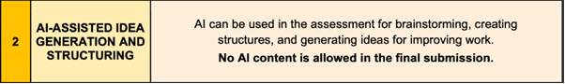

For example: you could use AI to search for and gather ideas for teaching specific aspects of a lesson, but it is not permitted to lift completed lessons online/using AI. You must submit your own planning for micro-teach assessments.

Attendance:
As you are undertaking a professional degree, it is important to attend all timetabled classes. Students who fail to satisfy attendance requirements will be referred to the Course Co-ordinator and if their attendance is deemed to compromise satisfactory completion of the course, they will be referred to the Board of Examiners who may decide that the course cannot be passed given the poor level of attendance. It is therefore essential that full attendance is achieved and where unavoidable absences take place, due to illness or other recognised extenuating circumstances, students must use the existing Student Absence procedure so that this can be considered when Boards of Examiners are reviewing attendance.

- Please check the BEd TEPP Programme Handbook for further details on all aspects of attendance and assessment.

All information is available on the Stranmillis Student intranet available at the following link:
https://stran.sharepoint.com/sites/StranmillisStudentIntranet

(Academic programmes drop-down menu; TEPP)

Assignment Submission
All assignments will be uploaded online via Canvas and further details on how to submit in this way will be provided during the course by the relevant subject tutors.

Regarding the online submission of assignments via Canvas, it is the student’s responsibility to ensure they submit:
- The most recent version of their assignment on Canvas as this is the copy that will be marked
- A completed electronic coursework coversheet with their assignment
- Their assignment to the correct course on Canvas otherwise submission requirements have not been fulfilled and late penalties may apply.

Late submission
Continuous assessment/coursework submitted after the deadline will be penalised at the rate of 5% of the total marks available for each calendar day late up to a maximum of five calendar days, after which a mark of zero shall be awarded. The example below illustrates this.
Example of work due on Thursday 16th December 5pm:
Work submitted before Thu 16th at 5pm | Full mark awarded
Work submitted between Thu 16th at 5pm and Fri 17th at 5pm | A deduction of 5 % will be applied
Work submitted between Fri 17th at 5pm and Sat 18th at 5pm | A deduction of 10 % will be applied
Work submitted between Sat 18th at 5pm and Sun 19th at 5pm | A deduction of 15 % will be applied
Work submitted between Sun 19th at 5pm and Mon 20th at 5pm | A deduction of 20 % will be applied
Work submitted after Mon 20th at 5pm | A mark of zero recorded

This excludes University closure days. The late penalty will apply to the continuous assessment/coursework component mark only and not to the overall module mark.
Exemptions shall be granted only if there are exceptional circumstances, and where the student has made a case in writing using the appropriate form and with appropriate supporting evidence if required (available here) by email to student-absence@stran.ac.uk within three working days of the deadline for submission or where a concession has been agreed on the grounds of a student’s disability. A list of guidelines on acceptable exceptional circumstances is contained in the Guidelines on Exceptional Circumstances. Extensions to deadlines shall be proportionate to the impact of the exceptional circumstances.
Accessing Reading List Resources Online via Course Reserves
Reading lists, which may include textbooks, journal articles, policies and/or guidance documents, will be provided by the lecturer(s). Students can access the resources included in the reading list(s) via the Stranmillis Library’s online Course Reserves service if the resource is available in an electronic format and all copyright requirements are complied with. The Course Reserves for this course can be accessed in 2 ways:

- Directly via this link https://stran.on.worldcat.org/courseReserves/course/id/19326935?page=3

- Indirectly by inserting the course or instructor name into the search box at this link: https://stran.on.worldcat.org/courseReserves/landing#!?courseSearchField=all&courseQuery=&includeInactiveCourses=true&includeActiveCourses=true&page=1

As per the reference-related criteria in the QUB Undergraduate Conceptual Equivalents Scale, all assessment components must be informed and supported by relevant and reputable references to achieve a pass mark. Consequently, all assessment components must show evidence of reading beyond the module material to obtain the higher marks.

Readings
Weekly reading lists, which may include textbooks, journal articles, policies and/or guidance documents, will be provided by the lecturer(s). As per the reference-related criteria in the Conceptual Equivalents, assignments must be informed and supported by relevant and reputable references to achieve a pass mark and they must show evidence of reading beyond the module material to obtain the higher marks.

Independent Study
All students are expected to complete at least 3-4 hours of independent study each week, however more is encouraged.
Canvas
Key resources, e.g., course guides and lecture presentations, will be posted on Canvas - the College’s Virtual Learning Environment (VLE). For pastoral reasons, lecturers and Advisers of Studies regularly check students’ usage of Canvas to ensure students are engaged in their learning. As no or minimal access can indicate non or low engagement and therefore a cause for concern, regular usage of Canvas is strongly recommended.

Professional Development Portfolio
- Each student will be assigned a personal tutor who will support them in developing their personal and professional skills. You will meet with your personal tutor during the weeks indicated in your Programme Handbook (and below for your convenience).
- Following each meeting you will complete or review and update your Professional Development Portfolio. The purpose of this is to continually develop you as a professional and to enrich your CV.
Time | Meeting | Student Follow-up
Induction | Students receive an email to confirm allocated personal tutor.
Week beginning 13th Oct | Meeting 1 with Personal Tutor (Group)  - Theme: Settling into university. | Student to start filling in their ‘Action Plan Template’.
Week beginning 17th Nov | Meeting 2 with Personal Tutor (Group)  - Theme: Developing skills. | Student to update their ‘Action Plan’ Template.
Semester 2 before School Placement | Meeting 3 Personal Tutor meets each student individually.  - Theme: review and feedback on assessment performance.  Student should print and bring their own academic transcript with them to the meeting.

School Based Work
In order to pass this module SPS1003, the SBW element of the course MUST be passed.
To pass school-based work you must show visiting tutors, your class teachers, teacher tutor and the principal of the school that you satisfy the following criteria, in line with the GTCNI Teacher Competences:
- Display a positive and enthusiastic attitude
- Be co-operative and helpful in school
- Establish good relationships with individuals and pupil groups
- Be able to plan individual lessons for a group of pupils or the whole class in subjects of the Northern Ireland Curriculum both independently and with peer/s
- Identify appropriate learning intentions for the lessons
- Incorporate and use the basic techniques of lesson presentation skills
- questioning
- explaining
- instructing
- creating and using resources, including ICT
- using the whiteboard and/or interactive whiteboard
- assessing pupils’ work in ways appropriate to the level of competence
- supervising pupils’ work
- behaviour management
- Evaluate lessons taught and use critical reflection to guide future planning
- Reflect on your observations of teaching and learning
You are required to teach 7-9 hours per week.

Exceptional Circumstances regarding School-Based Work
Students have the right to submit a letter to the Dr Patricia Eaton, Director of Teaching and Learning outlining mitigating circumstances which they believe affected their work and progress on SBW placements. Such letters must be received within 10 working days after the end of the block placement. Students and schools should be aware that these are ‘discoverable’ documents. These letters will be considered by the Exceptional Circumstances Committee which will advise the Board of Examiners before a final decision is made on a student’s mark/grade for SBW.

Child Protection and Safeguarding in School

Mrs Heather Lyle
Child Protection and Safeguarding Co-ordinator
Stranmillis University College, Belfast
h.lyle@stran.ac.uk Tel: 028 90 384 405

Children and young people have a fundamental right to be protected from harm.
Everyone in school plays a key part in protecting children and keeping them safe. There are three vital aspects to this role:
- Creating a safe and supportive environment for children
- Recognising pupils who are at risk or suffering from harm
- Taking appropriate action.
You can contribute to creating a safe and supportive environment for children through your work ethos and professionalism and in the way you communicate with and respond to children directly. By re-familiarising yourself with key indicators of adversity, you will increase the likelihood of recognising when a child is at risk or suffering from harm. Most importantly, if you are concerned about a child you can take appropriate action by reporting your concern immediately.
This information leaflet tells you what to do if you are concerned about a pupil during your school-based work and where you can get information or help. It is important that you become familiar with your school’s legal child protection and safeguarding duty. We strongly suggest that you use the check list contained in this information leaflet prior to and during your first day of school-based work (see below).
The school’s role in child protection:
- Your school will have a designated person/teacher for pastoral care or child protection. This person is responsible for all child protection matters affecting pupils at the school
- Your school must have a child protection policy. This may be contained within a safeguarding policy or as a separate document. You can ask for a copy of this if you would like to see it
- All schools in Northern Ireland must follow the legislation and guidance from the Department of Education and Education and Library Boards
- If a school is worried about a pupil’s welfare, they must refer this to the appropriate services, usually the Gateway Team to Children’s Social Work Service (see contacts below)
- Schools may wish to inform parents that they have made a referral but they should NOT contact parents if they think that this could put a child at risk of harm
Your role in child protection:
- In general, students must be observant of children’s learning, classroom behaviour and social relationships
- If you are concerned about the welfare of a pupil, you must report this to the designated person/teacher in your school immediately
- If the designated person/teacher is unavailable, you must report your concern to the school deputy designated teacher
- If a report about a pupil’s welfare is made during school-based work, you must inform a member of the College Child Protection and Safeguarding Team that you have done so.
- If you are unhappy with decisions made in school about your concern, you must report this to any member of the College Child Protection and Safeguarding Team immediately
- If you are concerned about a child, you should NOT approach the parent/guardian or discuss your concern with anyone else unless designated i.e. designated teacher.

School-based work checklist
- Read the NSPCC child protection document
- Read the College Child Protection and Safeguarding Policy (internal website)
- Revisit your child protection class notes and presentations
- Read your school Child Protection Policy
- Find out who the school Designated Teacher is
- Ensure you keep a copy of this information leaflet at all times
- Keep a note of contacts handy at all times
- Relax, take a deep breath and good luck with your visit.

Child Protection and Safeguarding Team 2023 – 2024

Heather Lyle  Child Protection & Safeguarding Co-ordinator | Central Building First Floor  Tel: 028 90 384 405  Email: h.lyle@stran.ac.uk
Noel Purdy  Deputy Child Protection &  Safeguarding Co-ordinator   | Stranmillis House, Second Floor  Tel: 028 90 384 305  Email: n.purdy@stran.ac.uk
Michael Ievers (Post-Primary) | Orchard Building First Floor  Tel: 028 90 384 474  Email: m.ievers@stran.ac.uk
  Rachel Campbell (Primary & HPAS) | Orchard Building Top Floor  Tel: 028 90 384 443  Email: r.campbell@stran.ac.uk
  Andy Brown (International) | Central Building Ground Floor  Tel: 028 90 384 259  Email: a.brown@stran.ac.uk
  Anita Gracie (PGCE) | Central Building First Floor  Tel: 028 90 384 391  Email: a.gracie@stran.ac.uk
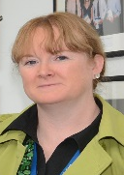  Brenda McKay-Redmond (ECS) | Central Building First Floor  Tel: 028 90 384 426  Email: b.mckayredmond@stran.ac.uk
Other Internal Contacts:
Dr Irene Bell, TEd Post Primary Chair
I.Bell@stran.ac.uk Tel: 028 90 384 388
Mr Andy Brown, TEd Primary Chair
a.brown@stran.ac.uk Tel: 028 90 384 259
Dr Noel Purdy, Head of Education Studies
N. Purdy@stran.ac.uk Tel: 028 90 384 326
External Contacts:
PSNI Inquiry Tel: 0845 600 8000
PSNI Crimestoppers Tel: 0800 555 111, Text: 180000.
Gateway to Children’s Social Work Service Tel: 028 9050 7000.
Northern Ireland Social Services Departments (see attached).

Insert school details for easy access:

Name of Designated Teacher:

Designated Teacher contact:

Appendix 1 LEVEL 1 ASSESSMENT CRITERIA

Stranmillis University College Marking Criteria for Level 1 Grade Descriptors
Conceptual Equivalent | % Pt | Mark Band |  | Level 1 Criteria
Exceptional 1  High/Excellent I  (in addition to criteria for Definite/low 1) | 97  92 | 95-100  90–94 |  | Excellent answer which:  - Is comprehensive and accurate  - Is presented in a clear and cogent manner  - Makes full reference to appropriate material  - Makes effective use of language  - Displays some of the following characteristics:  - integration of a wide range of learning resources  - originality of exposition or treatment  - evidence of insight  - critical evaluation
Definite I  Low I | 87 | 85-89
Definite I  Low I | 82 | 80-84
Definite I  Low I | 77 | 75-79
Definite I  Low I | 72 | 70-74
High 2.1  Definite/solid 2.1  Low/clear 2.1 | 68  65  62 | 67–69  64–66  60-63 |  | Very good answer which:  - Is generally accurate and reasonably detailed  - Displays a good understanding of the main principles and a reasonable grasp of details  - Shows strong and coherent argumentation  - Is presented in a logical fashion  - Makes frequent reference to appropriate material  - Makes effective use of language
High 2.2  Definite/solid 2.2  Low/clear 2.2 | 58  55  52 | 57-59  54–56  50–53 |  | Good answer which:  - Is reasonably accurate and well informed, albeit with some minor omissions or inaccuracies  - Is limited to the main issues and based on a limited range of learning resources  - Makes some reference to appropriate material  - Makes acceptable use of language, with some  minor inaccuracies
High 3rd | 48 |  | 47-49 | Adequate answer which:  - Displays evidence of understanding of the main principles in broad terms.  - May contain important inaccuracies or omissions.  - May lack a coherent structure.  - May answer the question indirectly or may lack supporting evidence.  - Makes minimal reference to relevant material.  - Shows poor use of language, although the meaning is understandable.
Definite 3rd | 45 | 44-46
Low 3rd | 42 | 40-43
Marginal fail | 37 | 35-39 |  | Marginally failing answer which:  - Displays a very limited understanding of the aim of the question  - Is sparse in material and lacking in organisation  - Contains material that is inappropriately used or of limited relevance  - Proceeds by way of assertions unsupported by appropriate evidence  - Shows poor use of language with significant grammatical and other errors
Weak fail  Poor fail  Little of merit | 29  19  7 | 25-34  15-24  1-14 |  | Unsatisfactory, poor answer which:  - Shows a complete lack of understanding of the question  - Provides very little of any relevance and value to the question  - Makes an incoherent argument  - Shows poor use of language with significant grammatical and other errors
Nothing of Merit | 0 | 0 |  | Nil Submission; or, answer meeting none of the necessary requirements with;  - No material of value to the question asked  - No recognition of the question

Appendix 2 E-SCHOOL BASED WORK FOLDER
You must maintain an e-SBW file in which you will record and analyse the information gathered and the activities carried out during your 7-week block of School Based Work. The artefacts contained in your portfolio will take a range of forms, depending on the nature of the task, from readings from the literature, through diagrams and personal observations, to material from your teacher and official material from your school.
Elements for inclusion in the SBW file:
- General information sheet including all personal details (as below)
- School documentation/policies/prospectus
- For each class you are teaching you should include:
- Class list, seating plan
- Link to subject specification, statements of minimum entitlement, curriculum guidance material …. as appropriate
- Individually dated lesson plans for each session: these must include link to curriculum (as above), learning intentions, success criteria, introduction, development and conclusion, resources, key questions, strategies and assessment/homework
- Lessons should provide evidence of having incorporated cross curricular skills and thinking skills and personal capabilities
- 1 copy only of all resources/activity sheets/assessment activities you are using during class (It is useful to store duplicate copies of these resources in a separate file or folder)
- 1 post-lesson review/evaluation to be completed per day. Please ensure you date and label these appropriately
At the front of your SBW file, you should incorporate a general information sheet which includes the following details:
PERSONAL DETAILS
NAME

student number

SCHOOL ADDRESS & PHONE NUMBER
COLLEGE MAIN TUTOR

MAIN/SECOND SUBJECT STUDIED
SCHOOL CONTACTS:
- SCHOOL PRINCIPAL

- TEACHER TUTOR

- CLASS TEACHER/S
Appendix 3 COMPETENCE DESCRIPTORS FOR TEACHING

These are the competences used when completing the Report on Teaching form and also the performance indicators in each over-arching competence area.
PREPARATION | CLASSROOM PRACTICE  TEACHING TECHNIQUES | CLASSROOM PRACTICE  CLASSROOM MANAGEMENT | EVALUATION
• Plans appropriate lessons within teaching programmes  • Can justify the selection of material in terms of curricular principles and child development  • Plans teaching strategies appropriate to the age, ability, interests, experiences and attainment level of the pupils and to the objectives of the lesson  • Prepares appropriate learning materials for children | • Employs a range of teaching strategies appropriate to the age, ability, interests, experiences and attainment level of the pupils and to the objectives of the lesson  • Captures and maintains pupils’ attention, interest and involvement  • Questions pupils effectively,  responds and supports discussion  • Provides feedback in a constructive manner  • Makes appropriate use of resources including ICT | • Teaches in whole class, group, pair or individual modes as appropriate for particular learning experiences  • Maintains pupils’ motivation  • Establishes good classroom rapport.  • Establishes clear rules and  expectations  • Deals effectively with pupil behaviour  • Identifies and responds to individual differences  • Manages own time and pupil time effectively  • Manages play and activity-based learning when appropriate | • Uses outcomes to evaluate teaching and plan for the future  • Can justify teaching methods used  • Provides pupils with regular feedback on their progress in a constructive manner which fosters their self-confidence and self-esteem  • Uses different methods of assessment as appropriate  • Assesses and records pupils’ performance in a systematic manner, using attainment targets and level descriptors where necessary  • Demonstrates awareness of the importance of informed critical reflection in evaluating his or her professional practice

COMPETENCE DESCRIPTORS FOR TEACHING (continued)

The following are the criteria used to differentiate the grades. These are used by University College Tutors and schools.

Grade A* Students in this elite group might be distinguishable from those in the ‘A’ category by more consistent or pervasive evidence of flair or originality in all the competence areas.
Grade A Very high level of proficiency in all the major areas with occasional evidence of flair and originality.
Grade B Very good / high level of proficiency in all major competence areas: typically little support or no support would be required at this stage.
Grade C Demonstrates consistently satisfactory level of performance in all major competence areas; some support still required.
Grade D Demonstrates a minimal level of capability for coping adequately with respect to preparation and implementation; considerable support still required.
Grade F Consistently low or otherwise unsatisfactory performance with regard to practical teaching.

Appendix 4 LESSON PLAN TEMPLATE
(available on Canvas)
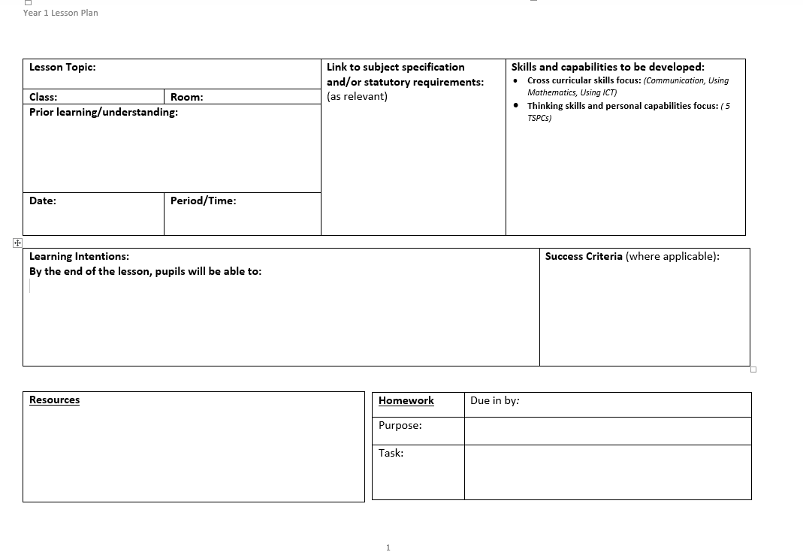
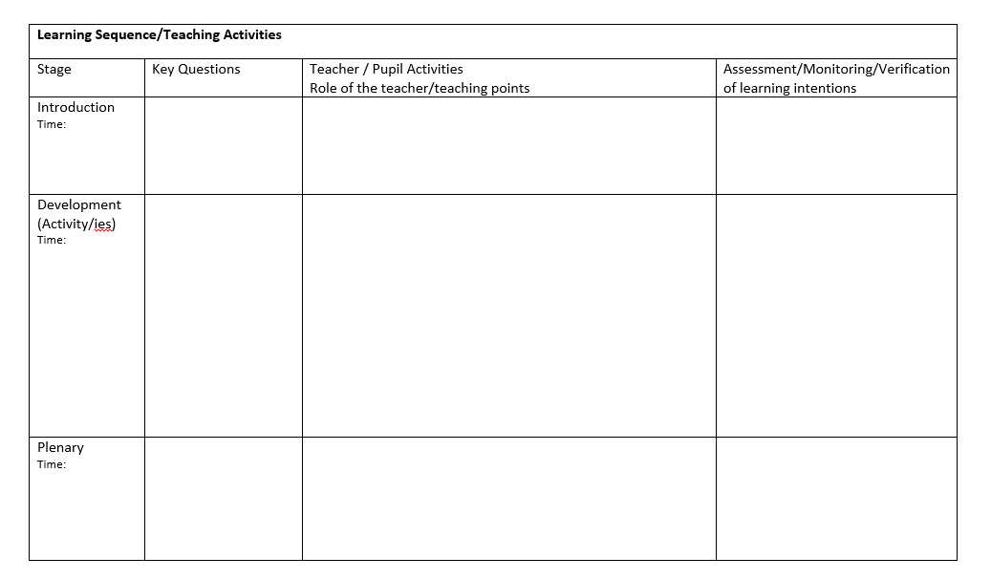

Appendix 5 SBW: REPORT ON TEACHING FORM
(available on Canvas)
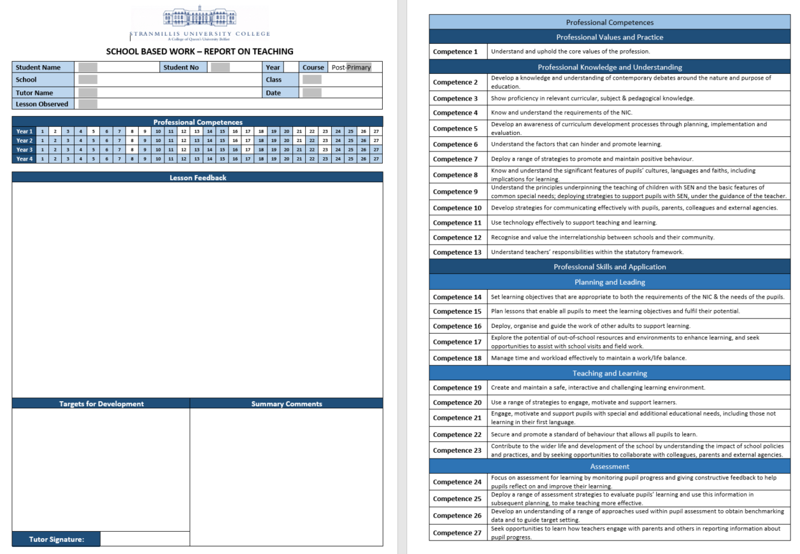
Appendix 6 SBW TIMETABLE TEMPLATE
(available on Canvas)


Appendix 7 LESSON OBSERVATIONS
(available on Canvas)
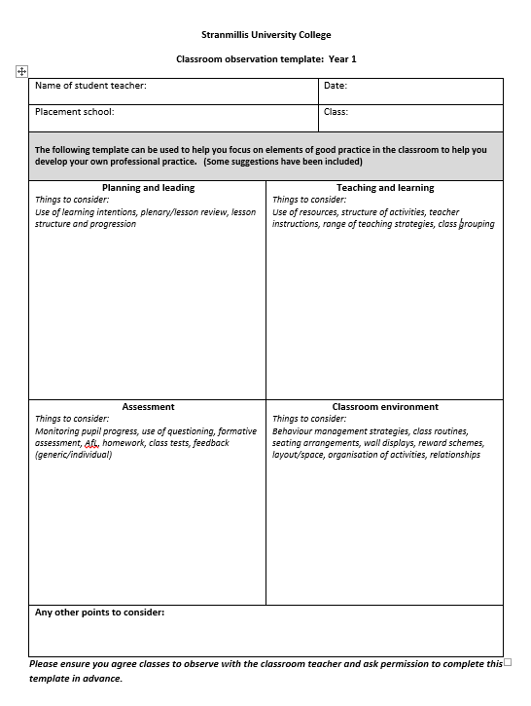
Appendix 8 OBSERVATION DAYS IN SCHOOLS
(available on Canvas)
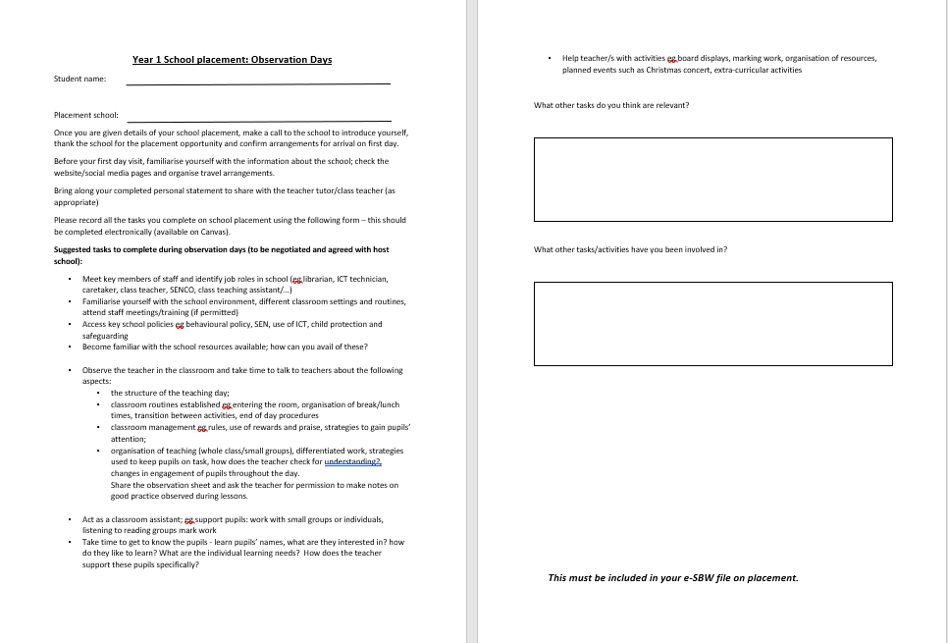
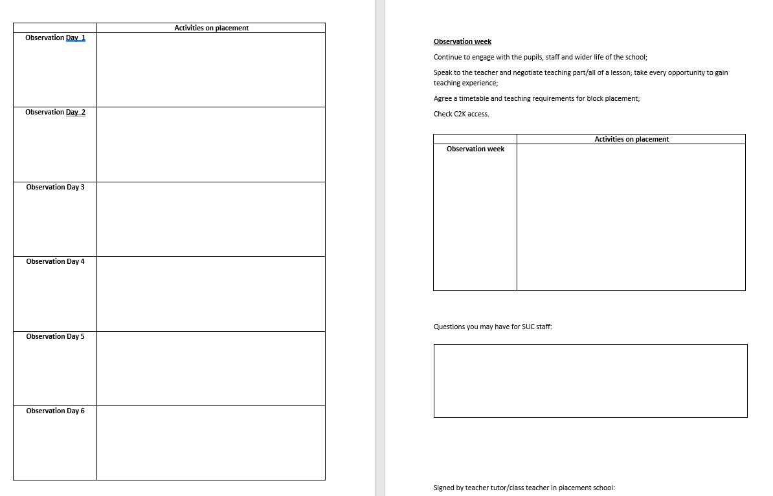

Appendix 9 STUDENT PERSONAL STATEMENT
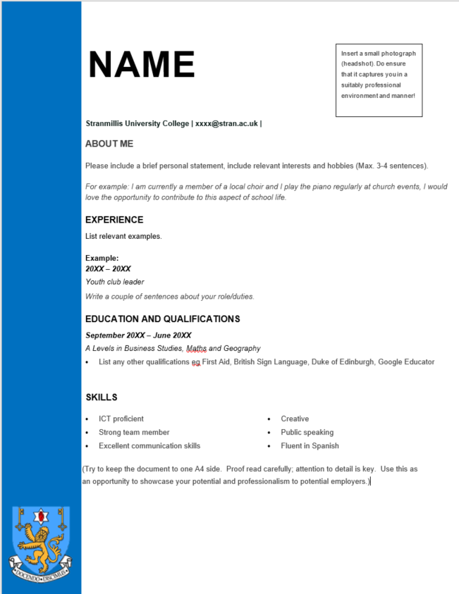
(available on Canvas)

