Bachelor of Education Primary Year 1
SPS1005
Professional Studies and Placement 1



School Based work - Block Placement Spring 2026

Information Booklet for students

Placement Dates – Spring 2026
If possible, unless the school needs to make different arrangements:
Block 1 – FS/KS1 - 4 weeks - Monday 9th Feb – Friday 6th March
Block 2 – KS2 - 3 weeks - Monday 9th March – Friday 27th March

First Block Teaching Pattern
FS/KS1 - 4 weeks
- Monday 9th Feb observation day
- Tuesday 10th Feb: observation day
- Wednesday 11th Feb onwards: teach 2 lessons per day

Second Block Teaching Pattern
KS2 - 3 weeks
- Monday 9th Mar Observation Day
- Tuesday: 10th Mar observation day
- Wednesday: 11th Mar onwards: teach 2 lessons per day

If your pattern deviates from this, make sure that you inform your College tutor about what is happening.

RE Certificate: Year 1

- Additional Placement for those undertaking Certificate in Religious Education
Monday 25th May – Friday 12th June

- Students undertaking the Certificate in Religious Education should have the opportunity to teach Religious Education during all their placements.

SBW Teaching File

- Create an SBW teaching file on your laptop / computer (as opposed to printing it all out). Store it in OneDrive and share the link with your College tutor.

- Your teaching file represents a portfolio of evidence which is reflective of your developing competence in and understanding of the ‘plan-do-review’ cycle, but also is indicative of your professionalism as a teacher. It should be personal to you and to the classes that you are teaching. It should therefore be well organised, carefully laid out and should exhibit high standards of presentation.

- Your College tutor will need to see the contents of your file during visits, but you should be sharing and discussing the file with your class teachers (and maybe the school’s principal or the teacher responsible for students) on a regular basis.

- It is YOUR responsibility to provide staff with access to your SBW file when they visit. For example you might have everything on your own laptop or have it ready to view on a school computer in the classroom. (Some College laptops are available for loan from IT Services.) If there are issues with online access when in your school, download to your desktop but remember to upload all new additions to OneDrive.

- Your teaching file must be kept up to date on a daily basis during SBW. It is integral to the assessment of your placement. At the bottom of the SBW Report Form which tutors will complete following their visits it states:
The following areas will be considered before deciding on a grade:
1. Review of planning and preparation in the file by the tutor
2. Classroom observations by the tutor
3. Pre- and post -observation discussions or professional learning conversations between student and tutor
4. Feedback from school
5. Reflections on teaching, as appropriate for each module
6. Demonstration of competences

The following areas will ALSO be considered before deciding on a grade:
Critical Self-reflection Ability to work independently
Flair and originality Demonstration of core values
Year-specific issues (see module guide)
- Print out a copy of the lesson plan for any lessons that will be observed by a College tutor.

- Only write lesson plans for lessons that you will actually teach. You are expected to teach TWO lessons per day. However events such as day trips, visiting groups or mornings at the swimming pool will mean that you won’t be able to teach your two lessons - that’s OK. You can still learn by taking part and helping out in these other activities.

SBW File – folder structure
Create a folder on your computer called:
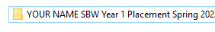
YOUR NAME – SBW Year 1 - Placement Spring 2026
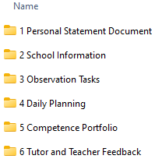

Within this folder create the following sub-folders:

What goes in each of these folders is set out on the following pages.

- Personal Statement Document Folder

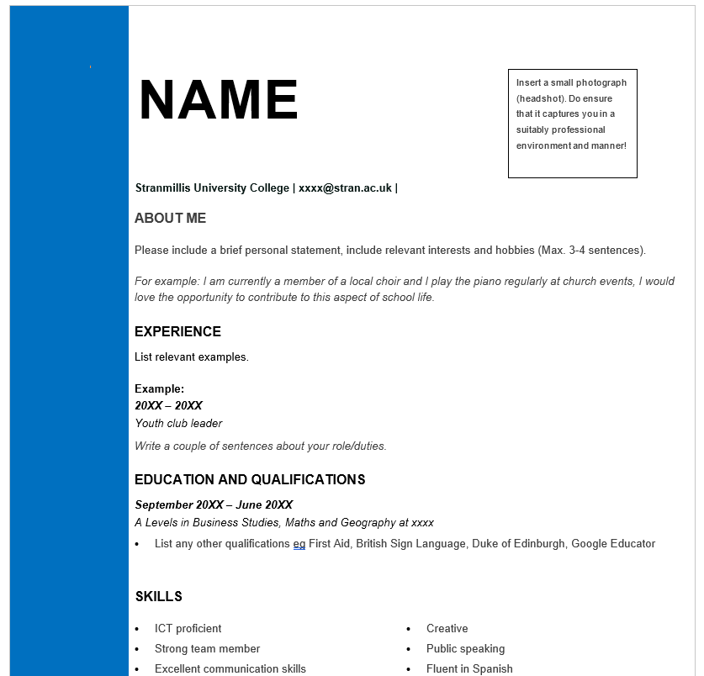
2. School Information folder
- A Word document with the school name, principal’s name, teachers’ names,
class information (first names of children only), any other relevant school information
Ask your teacher about getting electronic copies of the following school policies and
put them in the School Information folder:
- Safeguarding and Child Protection Policy
- Pastoral Care Policy
- Marking and Feedback policy
- Positive Behaviour Policy
- Health and Safety Policy
We understand that the school may prefer that students simply read these documents rather than have a copy; in that case, add a sentence listing the policy documents that you have read.
For your second class you only need to include class information in this folder relevant to the class to which you have transitioned.
Please give every document a clear filename.

3. Observation Tasks folder
- Notes you have gathered during your Monday visits for the tasks set each week.

4. Daily Planning folder - create a folder for each week:
In each week’s folder include
- The 2 lesson planners for each day (see template on Canvas)
- Any lesson resources – e.g. worksheets, PowerPoints etc.
- Samples of children’s work if possible/applicable (these can be photos)
- Any other materials or information relevant to the lesson
Please give every document a clear filename, e.g. Fri 13 Feb Literacy Lesson Plan
Fri 13 Feb Literacy PowerPoint
Fri 13 Feb Literacy worksheet

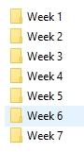


5. Competence Portfolio folder
GTCNI Competences
The GTCNI booklet ‘Teaching: the Reflective Profession’ is in the PS&P 1 course in Canvas and also can be found at this link:
https://gtcni.org.uk/cmsfiles/Resource365/Resources/Publications/The_Reflective_Profession.pdf
Every year we ask students to reflect on what competences they have achieved by keeping a working document during placement, noting whenever they are generating evidence for each GTCNI competence.
For example, Competence 20 states:
Use a range of teaching strategies and resources, including eLearning where appropriate, that enable learning to take place and which maintain pace within lessons and over time.
If you then produce a really good lesson plan that demonstrates effective e-learning, you may wish to include a brief explanation and attach an image of the plan as evidence of Competence 20 in the Competence Portfolio.
The Competence Portfolio can be downloaded from Canvas
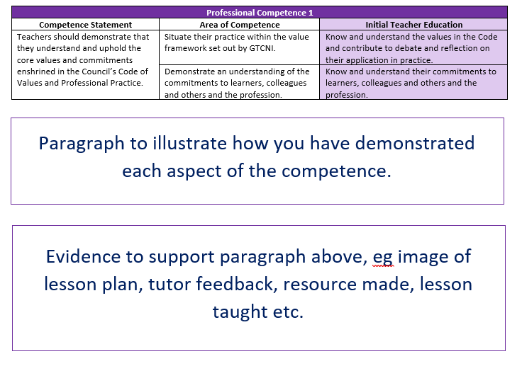
See the next page for the Competences to be focussed on in Year 1.

The following competences are those which Year 1 Primary students should concentrate:

Professional Competence 1: Understand and uphold the core values of the profession

Professional Competence 2: Develop a knowledge and understanding of contemporary debates around the nature and purpose of education.

Professional Competence 3: Show proficiency in relevant curricular, subject & pedagogical knowledge.

Professional Competence 4: Know and understand the requirements of the NIC.

Professional Competence 6: Understand the factors that can hinder and promote learning.

Professional Competence 10: Develop strategies for communicating effectively with pupils, parents, colleagues and external agencies.

Professional Competence 11: Use technology effectively to support teaching and learning.

Professional Competence 14: Set learning objectives that are appropriate to both the requirements of the NIC & the needs of the pupils.

Professional Competence 15: Plan lessons that enable all pupils to meet the learning objectives and fulfil their potential.

Professional Competence 18: Manage time and workload effectively to maintain a work/life balance.

Professional Competence 19: Create and maintain a safe, interactive and challenging learning environment.

Professional Competence 20: Use a range of strategies to engage, motivate and support learners.

Professional Competence 25: Deploy a range of assessment strategies to evaluate pupils’ learning and use this information in subsequent planning, to make teaching more effective.
6. Tutor and Teacher Feedback folder

- Any tutor report forms you have received and any written feedback or advice that your teachers or tutors have given you can be stored here. It is always useful to have this information easily accessible when setting targets for yourself

Online File
Before Placement Starts:
Ensure that your file with the above folder structure is stored in OneDrive before the start of SBW – by 5:00pm on the Wednesday before placement begins (4th February) – and share with your College tutor. This link should remain live throughout the placement block. Upload planners, materials, etc. to this every few days so that tutors can monitor student progress as required.
At the end of SBW:
Ensure that all of the contents of your file are on OneDrive so that your tutor can have a final look through it. The deadline for doing this is 5pm on Monday 30th March. If you have been keeping it all up to date as you should have been, there will be nothing much to do to your file after the end of SBW except for the final evaluation annotations and completion of the Competences Portfolio.

Student Support and Mid-Placement Review Day
Some tutors may invite students to a ‘check-in’ meeting periodically across the 7 weeks and this will most likely take place via Teams and after school hours. It can be a good opportunity to address common issues and seek support from other students as well as the tutor, and will give students the opportunity to connect. This may not happen with every tutor, so the onus may be on you to make contact with any queries you may have. Your tutor is there to help.
For the first time this year a Mid-Placement Review Day will be scheduled. This will take place during week 4 of your block placement (probably Friday 6th March). This is in place of a day in school; therefore, attendance is compulsory and will be recorded.

