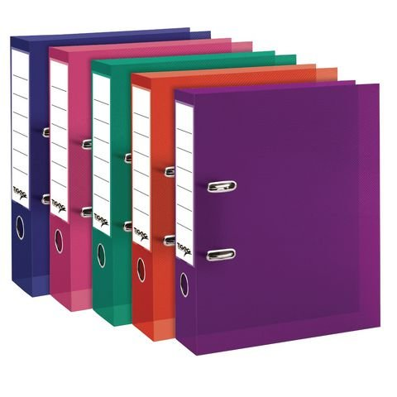

Online Electronic Teaching file


Your teaching file represents a portfolio of evidence that is reflective of your developing competence in and understanding of the ‘plan-do-review’ cycle, but also is indicative of your professionalism as a teacher. It should be personal to you and to the classes that you are teaching. It should therefore be well organized and exhibit high standards of presentation.


Your teaching file for the block placement will be an electronic file of evidence that you will share with your tutors and your class teachers. The teaching file must be kept up-to-date on a daily basis and should be readily available for tutors to view at all times. Your electronic teaching file will be integral to the assessment of your placement and your tutor will be accessing your folders regularly, so you must maintain your folders carefully.

Only you and your tutor will have access to your Placement folder on OneDrive, however you may be asked to share your planning and reflections etc. with a member of the school staff.

Please follow the instructions below to set up your e-file on OneDrive:

Create a file in your Stranmillis OneDrive called:

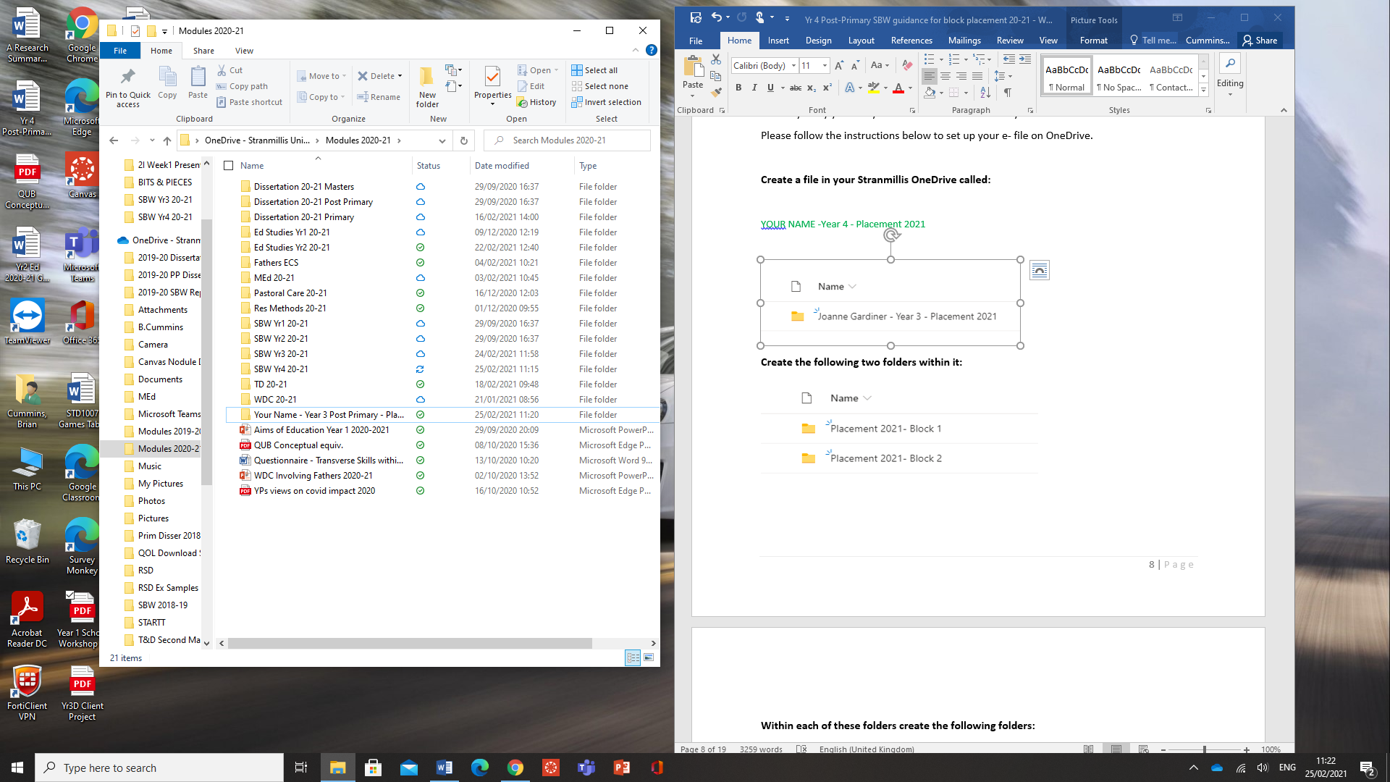

Within this folder create the following folders:
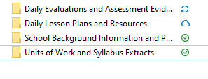
In the Daily Lesson Plans and Resources folder create the following folders:
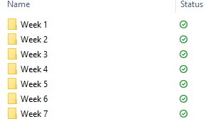
In each of the weeks of the Daily Lesson Plans and Resources folder, create the following folders for each day – these will include your lesson plans and lesson resources. You may wish to further subdivide this folder if teaching a number of lessons on the one day.
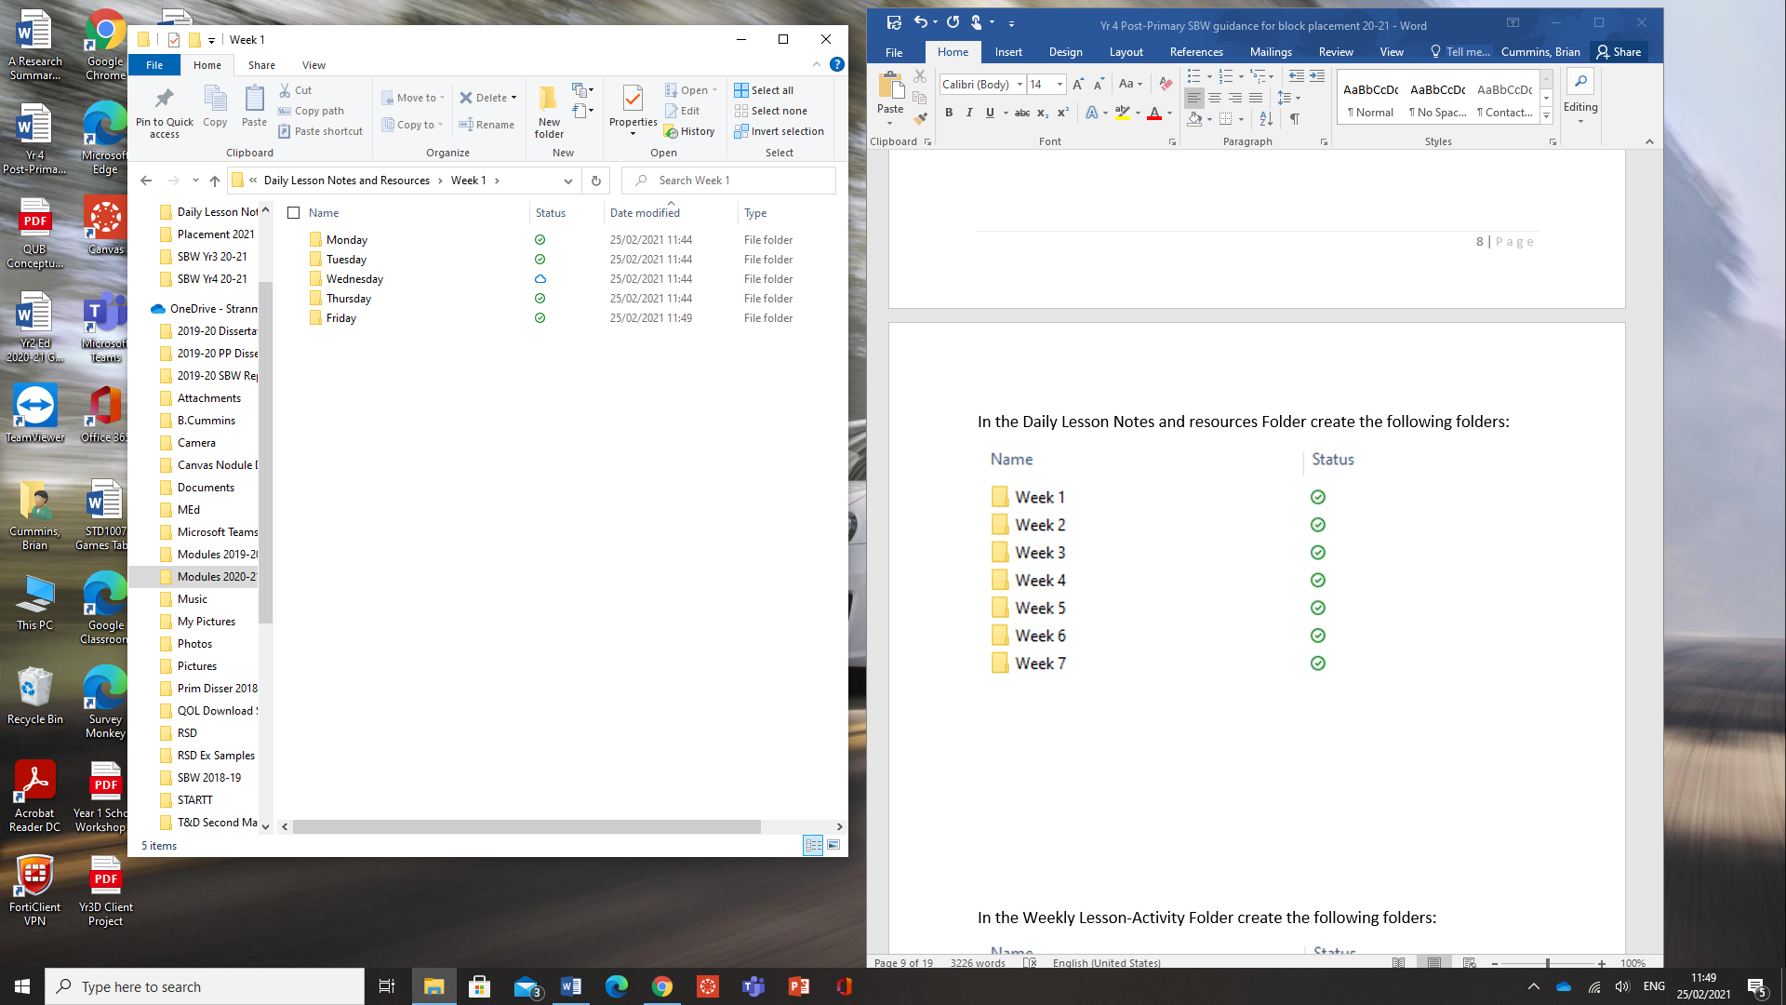
In the daily ‘Evaluations and Assessment Evidence’ folder, create the additional folders below that contain your written evaluations plus evidence to support your claims made, e.g. copies of written materials, photographs, links.
You should be making direct reference to the teacher competencies in your daily reflections. You should also place any evidence you have of any formative and summative assessment of pupils and strategies for Assessment for Learning’ (AFL). The evaluation document will provide a written reflection on your identification of:
- 2 strengths and 1 Area for Development (AFD)
- action required for AFD and follow-up action in subsequent evaluations.

When writing this, refer to the teaching competences that Stranmillis assesses on placement.

Assessment Evidence folder – Additional Guidance
Specific annotations on lesson plans and schemes of work should occur on a daily basis to demonstrate your ability to assess and monitor pupil progress, however your teaching file should also contain examples of other methods that showcase your ability to track the learning that has or has not taken place.
We recognise that collating assessment information will be challenging on this placement and will be different in each school. Discuss with teachers their protocols and processes for tracking children and monitoring progress. Can you engage with the ‘remote’ approaches that schools are using to gather assessment evidence?
The following are examples that you can also consider:
- Exemplars of pupils’ work - be selective. If possible, select examples that reflect the different ability levels within your classes. Annotate the samples that you select to indicate the learning that has or has not taken place and the future learning targets for the child/group

- Photographs of children’s work that identify and document the learning that has taken place

- Post-it notes

You need to show evidence of some of the above approaches in order to demonstrate your ability to meet the assessment area of competence effectively.

