Your teaching file for the block placement will be an electronic SBW file of evidence that you will make available to your placement tutors and your class teachers/school principal.
All students must share the link to their digital file with their main tutor by 5pm on the Wednesday before placement begins (4th Feb 2026 Post-Primary students). This link should remain live throughout the placement block so that tutors can monitor and support student progress as required.
Your teaching file must be kept up to date on a daily basis and should be readily available for tutors to view during placement visits. Your electronic teaching file will be integral to the assessment of your placement so you must maintain your folders carefully.
Whilst the practice that is observed during each visit is important, the final mark will be a holistic one, awarded at the end of the placement, which reflects the journey travelled throughout the placement block. It is made up of the following elements:

- Lesson observations conducted by the Placement Supervisor
- Teaching file
- Analytical annotations added to planning documents that reflect on practice
- Competence Portfolio / Grid
- Pre and Post-lesson discussions between the supervisor and student
- Discussions between the supervisor and class teacher / school principal
- Discussions between the supervisor and the APA (where applicable)
- Report from the school
During each visit, students must ensure that hard copies of any materials relevant to the lesson being observed are provided for the tutor.

This file must be made available for your tutor to view on an electronic device during your tutor visits (not OneDrive; a phone is not acceptable);

At the end of the placement block, all of the required paperwork and documentation is to be completed by 5pm on the Monday after the placement block ends (ie 30th March 2026 for BEd Primary and Post-Primary students). If a student is required to make up any missed days after the placement block, the amended file completion date will be discussed and agreed with the main tutor.
Guidance on formatting
Portrait pages and landscape pages: lesson plans and scheme grid pages definitely look better in landscape format. However other text such as introductory sections etc. which are not in tables/grids should be on a portrait page. We do not want to read text which would normally be on portrait pages spread across a landscape page.
Therefore, you can do one of two things: firstly, you can create two or three separate Word documents, some portrait and some landscape to suit the content, and upload all of them; or alternatively, look into creating one Word document with both portrait and landscape pages in it. Then you can submit just the one document.
Have a look at this YouTube video which explains how to do this - it's all about sections and section breaks! This is a useful skill to know how to do anyway for future reference.
MS Word Tutorial: How to Insert one landscape page in a portrait document
Saving as PDFs: sometimes the formatting of documents with tables, grids, topic webs etc. can get messed up when you save them to the computer. One way round this is to save such documents as PDFs. When you have finished the document in Word, go to File … Save As … Save As Type … PDF.

In terms of the specific structure for your e-SBW folder, you must follow the instructions below carefully:
Create an e-SBW folder called:
YOUR NAME - Year 1PP - Placement 2026
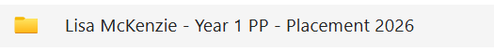
Within your folder, create the following sub-folders:
- School information
- Placement documentation
- Lesson plans and teaching resources
- Placement assessment
What goes in each of these folders is set out on the following pages.
Placement information
School Information Folder
- A word document with the should include all relevant contact details eg name of the school, name of the principal, name of link teachers eg class teacher and teacher tutor
- Please gather the relevant school policy documents in electronic format (names may vary between schools) and familiarise yourself with procedures
  - Child protection and safeguarding and policy
  - Pastoral Care Policy
  - Health and safety policy
  - Teaching and learning policy
  - Remote learning Policy (if applicable)
  - Marking and feedback policy
  - Behaviour for Learning/Positive behaviour policy
  - Class information (first names of children only)
- Any other relevant school information
Please name every document clearly.
Ensure you engage with each of these and know what your role and responsibility is.
Please include:
- Personal statement
- Observation sheet from day visits and observation week
- Any observed lesson evaluations and notes
- Any teacher evaluations
- Complete a weekly overview sheet outlining your engagement with teaching and relevant classroom-based activities. Example below:

Week | Overview of teaching eg hours and subject area (topic) | Additional classroom-based activities | Engagement in wider aspects of school life
Week 1  (3 days) | 2 hours literacy  3 hours WAU  2 hours PDMU  1 hour ICT  1 hour PE  Total - 9 hours | - Break duty with member of staff  - Changed topic noticeboard  - Small group support for reading | Help out with coding club on Thursday after school
Week 2
(5 days)

Any other relevant documentation?

Within the ‘Lesson plans and teaching resources’ folder, create the following folders:
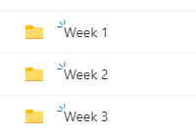

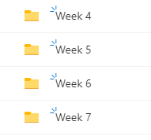

Within each weekly folder create a folder for each day:
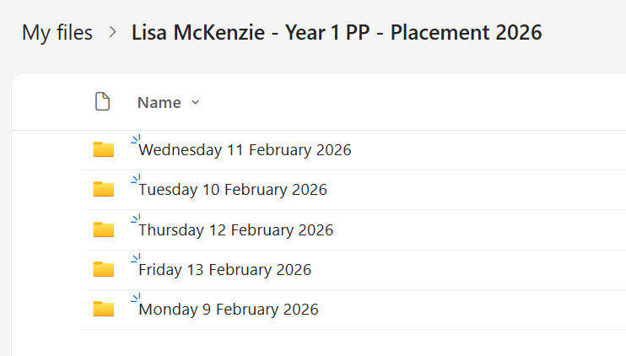
Within each daily folder, create separate folders for each lesson:
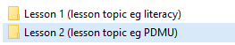
- In each folder include the lesson plan (see template on Canvas) and the associated learning and teaching resources. It may be useful to include examples of tasks/completed work (exemplars of children’s work: photos/scans – ensure you have written permission from the school included in your file) which showcase your ability to track whether the learning has or has not taken place.
Please give every document a clear filename with the lesson title and date; ensure these are kept up-to-date.

One post-lesson review per day is required.
Use the template with the electronic sticky notes (available on Canvas)
- Add daily analytical annotation to your planning documents to reflect upon elements of planning, monitoring and assessment of pupil learning and management of pupil behaviour. Signpost to appropriate documents in your file if relevant. Use these reflections to guide future planning. Ensure these are completed at the end of each day.

In your main e-SBW folder you will also need to create the following folder ‘Placement Assessment’:

In this folder create the following folders:
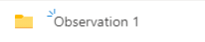

How will lesson observations work?
- You will be assigned a main tutor for your placement as normal. Your main tutor will carry out two observations and, on the basis of these, will construct two separate reports.
- Your allocated SBW tutor is your main point of contact, please attend any meetings they arrange and reply to emails in a timely manner.

Please include the following information in each observation folder:

- Lesson plan for the lesson you are teaching – this should also be available in hard copy format for you tutor during each placement visit
- Resources and materials for the lesson
- Post-lesson review
- Assessment evidence

Evidence from observation days
Please ensure you store the document outlining your activities completed during these days.

Remember to check the information carefully provided in the Guide to SBW and Year 1 PPL guide (both available on Canvas).

Remember to check the assessment requirements which are due for submission post-placement. This was discussed in class and is available on Canvas.

Wishing you all the best for your first placement.

